UNITED STATES

SECURITIES AND EXCHANGE COMMISSION
Washington, D.C. 20549

SCHEDULE 14A INFORMATION

Proxy Statement Pursuant to Section 14(a) of the

Securities Exchange Act of 1934

Filed by the Registrant ☒ Filed by a Party other than the Registrant ☐

Check the appropriate box:

- Preliminary Proxy Statement

- Confidential, for Use of the Commission Only (as permitted by Rule 14a-6(e)(2))

- Definitive Proxy Statement

- Definitive Additional Materials

- Soliciting Material under §240.14a-12

GRAHAM HOLDINGS COMPANY

(Name of registrant as specified in its charter)

(Name of person(s) filing proxy statement, if other than the registrant)

Payment of Filing Fee (Check the appropriate box):

- No fee required.

- Fee computed on table below per Exchange Act Rules 14a-6(i)(1) and 0-11.

  - Title of each class of securities to which the transaction applies: N/A

  - Aggregate number of securities to which the transaction applies: N/A

  - Per unit price or other underlying value of the transaction computed pursuant to Exchange Act Rule 0-11 (set forth the amount on which the filing fee is calculated and state how it was determined): N/A

  - Proposed maximum aggregate value of the transaction: N/A

  - Total fee paid: N/A

- Fee paid previously with preliminary materials.

- Check box if any part of the fee is offset as provided by Exchange Act Rule 0-11(a)(2) and identify the filing for which the offsetting fee was paid previously. Identify the previous filing by registration statement number, or the Form or Schedule and the date of its filing.

  - Amount Previously Paid:

  - Form, Schedule or Registration Statement No.:

  - Filing Party:

  - Date Filed:


1300 NORTH 17TH STREET | ARLINGTON, VA 22209 | (703) 345-6300

March 25, 2021

TO OUR SHAREHOLDERS:

You are cordially invited to the 2021 Annual Meeting of Shareholders of Graham Holdings Company (the “Company”), which will be held virtually on Thursday, May 6, 2021, at 8:30 a.m., Eastern Daylight Time. In order to be able to access the virtual meeting, please retain the 15-digit control number set forth on your proxy card or voting instruction form in order to verify your identity when accessing the virtual meeting. Details on how to participate are more fully described in the enclosed Proxy and are posted on our website at www.ghco.com. As always, we encourage you to vote your shares prior to the Annual Meeting.

Shareholders of record on March 17, 2021 can access the live webcast of the Annual Meeting on the day of the meeting by logging in at www.meetingcenter.io/243294754 using their control number and the password “GHC2021”. The 15-digit control number is located on the proxy card or voting instruction form. Measures are in place to enable the vast majority of shareholders who hold shares through a brokerage firm, bank or other entity to fully participate at the Annual Meeting using the control number on their voting instruction form and the password “GHC2021”. This option is provided as a convenience to such beneficial holders, and there is no guarantee that this option will be available for every type of beneficial holder. Those shareholders who hold shares through a brokerage firm, bank or other entity are advised to provide their voting instructions to these firms and register in advance to participate in the Annual Meeting no later than May 3, 2021.

At the Company’s 2021 Annual Meeting of Shareholders (the “Meeting”), there will be a report on the Company’s activities, and Directors will be elected for the ensuing year. In addition, the Class A Shareholders will have an advisory vote on whether to approve the compensation paid to the Company’s named executive officers for 2020.

It is important that your shares are represented at the Meeting. Please sign the accompanying Proxy and return it promptly in the envelope provided. If you plan to attend, kindly so indicate in the space provided on the Proxy. You may also vote your shares by telephone or on the internet. If you choose to vote your shares by telephone or on the internet, please follow the instructions in the enclosed Proxy.

Sincerely yours,
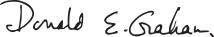

DONALD E. GRAHAM

Chairman

GRAHAM HOLDINGS COMPANY

Notice of Annual Meeting of Shareholders — May 6, 2021

The 2021 Annual Meeting of Shareholders of Graham Holdings Company will be held virtually on Thursday, May 6, 2021, at 8:30 a.m.,

Eastern Daylight Time, for the following purposes:

- To elect Directors for the ensuing year, as more fully described in the accompanying Proxy Statement.

- For the Class A Shareholders, on an advisory basis, to vote on whether to approve the compensation paid to the named executive officers of the Company for 2020.

- To transact such other business as may properly come before the Meeting or any adjournments thereof.

The Board of Directors of the Company (the “Board”) has fixed the close of business on March 17, 2021, as the record date for the determination of shareholders entitled to notice of and to vote at the Meeting.

It is important that your shares are represented and voted at the Meeting. Please sign and return your Proxy at your earliest convenience. You may also vote your shares by telephone or on the internet. If you choose to vote your shares by telephone or on the internet, please follow the instructions in the enclosed Proxy. You may revoke your Proxy at any time before it has been voted at the Meeting. You may vote at the Meeting even if you returned a Proxy, provided that you first revoke your previously voted Proxy.

In order to be able to access the virtual meeting, please retain the 15-digit control number set forth on your proxy card or voting instruction card. Shareholders of record on March 17, 2021 can access the live webcast of the Annual Meeting on the day of the meeting by logging in at www.meetingcenter.io/243294754 using their control number and the password “GHC2021”. Measures are in place to enable the vast majority of shareholders who hold shares through a brokerage firm, bank or other entity to fully participate at the Annual Meeting using the control number on their voting instruction form and the password “GHC2021”. This option is provided as a convenience to such beneficial holders, and there is no guarantee that this option will be available for every type of beneficial holder. Those shareholders who hold shares through a brokerage firm, bank or other entity are advised to provide their voting instructions to these firms and register in advance to participate in the Annual Meeting no later than May 3, 2021. Additional details on how to participate are described more fully in the enclosed Proxy and are posted on our website at www.ghco.com.

By Order of the Board of Directors,

NICOLE M. MADDREY

Secretary

March 25, 2021

Arlington, VA

GRAHAM HOLDINGS COMPANY

1300 North 17th Street, Suite 1700, Arlington, VA 22209

March 25, 2021

This Proxy Statement contains information relating to the 2021 Annual Meeting of Shareholders of Graham Holdings Company to be held virtually on Thursday, May 6, 2021, at 8:30 a.m., Eastern Daylight Time, or any adjournments thereof, for the purposes set forth in the accompanying Notice of the 2021 Annual Meeting of Shareholders. This Proxy Statement and the accompanying forms of Proxy and voting instructions are being delivered to shareholders on or about March 25, 2021. The Board of Directors of the Company is making this Proxy solicitation.

Important notice regarding the availability of Proxy materials for the Annual Meeting of Shareholders to be held on May 6, 2021. This Proxy Statement and the Annual Report to Shareholders are available at www.ghco.com.

QUESTIONS AND ANSWERS

- How can I participate in the virtual Meeting?

- Shareholders of record on March 17, 2021 can access the live webcast of the Annual Meeting on the day of the meeting by logging in at www.meetingcenter.io/243294754 using their control number and the password “GHC2021”. The 15-digit control number is located on the proxy card or voting instruction form. Shareholders may also vote by one of the other means described in these materials.

Measures are in place to enable the vast majority of shareholders who hold shares through a brokerage firm, bank or other entity to fully participate at the Annual Meeting using the control number on their voting instruction form and the password “GHC2021”. This option is provided as a convenience to such beneficial holders, and there is no guarantee that this option will be available for every type of beneficial holder. Those shareholders who hold shares through a brokerage firm, bank or other entity are advised to provide their voting instructions to these firms and register in advance to participate in the Annual Meeting no later than May 3, 2021. To register, shareholders must submit proof of proxy power (legal proxy) reflecting ownership of Graham Holdings Company stock along with your name and email address to Computershare. Proof of legal proxy may be submitted either by forwarding an email from your broker or by attaching an image of the legal proxy. Requests for registration should be directed to Computershare at legalproxy@computershare.com, labeled as “Legal Proxy” and must be received no later than 11:00 p.m. (EDT) on or before May 3, 2021. Requests for registration may also be mailed to Computershare at GHC Legal Proxy, P.O. Box 43001, Providence, RI 02940-3001. A registration confirmation email from Computershare will be sent to shareholders.

Participants in one of the Company’s 401(k) plans with Graham Holdings Company Class B Common Stock allocated to their account(s) (the Savings Plan for Graham Holdings Company, the Kaplan, Inc. Tax Deferred Savings Plan for Salaried Employees and the Kaplan, Inc. Tax Deferred Savings Plan for Hourly Employees) may join the Annual Meeting but may not vote their shares at the Meeting. Plan participants may vote by providing their voting directions to the plan trustee no later than 11:00 p.m. (EDT) on May 3, 2021.

Q: What am I voting on?

- You are voting on the election of Directors for a term of one year. A Board of nine Directors is to be elected, six by the holders of Class A Common Stock, voting separately as a class, and three by the holders of Class B Common Stock, voting separately as a class. All Directors will hold office until the next Annual Meeting or until their respective successors shall have been elected and shall have qualified or as otherwise provided in the bylaws of the Company.

In the event that any nominee withdraws or for any reason is not able to serve as a Director and you have submitted a Proxy, Timothy J. O’Shaughnessy, Wallace R. Cooney, Jacob M. Maas and Nicole M. Maddrey, acting as your proxies, may vote for such other person as the Board of Directors may nominate.

In addition, if you are a holder of Class A Common Stock, you are voting on whether to approve the compensation paid to the Company’s named executive officers for 2020. In accordance with rules of the U.S. Securities and Exchange Commission (the “SEC”), this vote is advisory in nature and non-binding.

Each of your shares entitles you to one vote with respect to each matter on which you may vote.

3

Q: What are the voting recommendations of the Board?

- The Board recommends voting for each of the nominated Directors listed on the Proxy card. The Board knows of no reason that would cause any nominee to be unable to act or to refuse to accept nomination or election.

The Board also recommends voting for the approval of the compensation paid to the Company’s named executive officers for 2020.

Q: Will any other matters be voted on?

- We are not aware of any matters to be voted on other than the election of Directors and the Class A Shareholder advisory vote on compensation paid to the Company’s named executive officers for 2020. If any other matter is properly brought before the Meeting and you have submitted a Proxy, Timothy J. O’Shaughnessy, Wallace R. Cooney, Jacob M. Maas and Nicole M. Maddrey, acting as your proxies, will vote for you at their discretion.

- How do I vote?

- There are four ways to vote:

  - By internet at www.investorvote.com. We encourage you to vote this way;

  - By toll-free telephone at 1-800-652-8683;

  - By completing and mailing your Proxy card; or

  - By voting at the virtual Annual Meeting, provided you first revoke your previously voted Proxy and follow the instructions on how to participate at the virtual Annual Meeting in the manner described in the Question “How do I participate in the virtual Meeting?” above.

If you vote by internet or telephone, your vote must be received before the polls are closed at the Annual Meeting. Your shares will be voted as you indicate. If you are a Class B Shareholder (other than as a participant in one of the Company’s 401(k) plans with Graham Holdings Company Class B Common Stock allocated to your account) and do not indicate your voting preferences, Timothy J. O’Shaughnessy, Wallace R. Cooney, Jacob M. Maas and Nicole M. Maddrey, acting as your proxies, will vote your shares in favor of the applicable nominated Directors. If you are a participant in one of the Company’s 401(k) plans with Graham Holdings Company Class B Common Stock allocated to your account, please see the Question below, “How do I vote if I participate in one of the Company’s 401(k) plans?” Please note that for participants in these plans, your voting direction must be received no later than 11:00 p.m., Eastern Daylight Time, on May 3, 2021, which is earlier than the time at which votes must be received for shares held outside of these plans.

If you are a Class A Shareholder and do not indicate your voting preferences, Timothy J. O’Shaughnessy, Wallace R. Cooney, Jacob M. Maas and Nicole M. Maddrey, acting as your proxies, will vote your shares in favor of the applicable nominated Directors and for approval of the compensation paid to the Company’s named executive officers for 2020.

Q: How do I vote if I participate in one of the Company’s 401(k) plans?

- As a participant in one of the Company’s 401(k) plans with Graham Holdings Company Class B Common Stock allocated to your account, you can direct the plan trustee how to vote Graham Holdings Company Class B Common Stock allocated to your account(s) on a proxy voting direction card, electronically through the internet or by telephone. These plans are the Savings Plan for Graham Holdings Company, the Kaplan, Inc. Tax Deferred Savings Plan for Salaried Employees and the Kaplan, Inc. Tax Deferred Savings Plan for Hourly Employees (the “Plan(s)”). Vanguard Fiduciary Trust Company serves as the trustee (the “Plan Trustee”) with respect to the Class B Common Stock allocated to accounts in the Plans. If you do not provide timely direction to the Plan Trustee or if you submit a proxy voting direction card and do not indicate your voting preferences, shares allocated to your account(s) will be voted by the Plan Trustee in the same proportion to those shares allocated to accounts of participants for which timely direction was received, unless contrary to the Employee Retirement Income Security Act of 1974, as amended (“ERISA”). Plan participants may join the Annual Meeting, but may not vote Plan shares at the Annual Meeting. If you wish to vote, whether you plan to join the virtual Annual Meeting or not, you should direct the Plan Trustee how you wish to vote your Plan shares no later than 11:00 p.m., Eastern Daylight Time, on May 3, 2021.

Q: Who can vote?

- You can vote if you were a shareholder of record as of the close of business on March 17, 2021 (the “Record Date”). If you hold shares in street name, your broker, bank or other nominee will instruct you as to how your shares may be voted by proxy,

4

including whether telephonic or internet voting options are available. You may not vote shares held in street name at the Meeting unless you have a Proxy executed in your favor by your broker, bank or other nominee or unless you are able to participate at the Annual Meeting. As described above, measures are in place to enable the vast majority of shareholders who hold shares through a brokerage firm, bank or other entity to fully participate at the Annual Meeting using the control number on their voting instruction form and the password “GHC2021”. This option is provided as a convenience to such beneficial holders, and there is no guarantee that this option will be available for every type of beneficial holder. Those shareholders who hold shares through a brokerage firm, bank or other entity are advised to provide their voting instructions to these firms and register in advance to participate in the Annual Meeting no later than May 3, 2021.

Both Class A Shareholders and Class B Shareholders are entitled to vote on Proposal 1: Election of Directors. In accordance with the Company’s constitutive documents and under Delaware corporate law, only Class A Shareholders are entitled to vote on Proposal 2: Advisory Vote to Approve 2020 Compensation Awarded to Named Executive Officers.

If you are a participant in one of the Company’s 401(k) plans with Graham Holdings Company Class B Common Stock allocated to your account, you will be eligible to vote Class B Common Stock allocated to your account on Proposal 1: Election of Directors.

- Can I change my vote?

- Yes. You can change your vote or revoke your Proxy at any time before the Meeting:

  - By entering a new vote by internet or telephone;

  - By returning a later-dated Proxy card; or

  - By voting at the virtual Meeting, provided you first revoke your previously voted Proxy and follow the instructions on how to participate at the virtual Meeting in the manner described in the Question “How can I participate in the virtual Meeting?” above.

If you are a participant in one of the Company’s 401(k) plans with Graham Holdings Company Class B Common Stock and wish to change your vote or revoke your Proxy, you must do so no later than 11:00 p.m., Eastern Daylight Time, on May 3, 2021, by instructing the Plan Trustee in a manner described in the Question “How do I vote if I participate in one of the Company’s 401(k) plans?” above.

Q: What vote is required to approve a proposal?

- Directors will be elected by a plurality of the votes cast at the Meeting. This means that the six Class A Shareholder nominees receiving the highest number of votes cast and the three Class B Shareholder nominees receiving the highest number of votes cast shall be elected. You do not have the right to cumulate votes in the election of Directors. A properly executed Proxy marked “WITHHELD” with respect to the election of one or more Directors will not be voted with respect to the Director or Directors indicated, although it will be counted for purposes of determining whether a quorum is present at the Meeting.

While Proposal 2 to approve the 2020 compensation awarded to the Company’s named executive officers is non-binding and advisory in nature, it will be approved only on the favorable vote of a majority of the Class A Shareholders present or represented at the Meeting.

Broker non-votes will have no impact on the voting results for any of the proposals presented at the Meeting, and abstentions will have the effect of a vote against Proposal 2 to approve the 2020 compensation awarded to the Company’s named executive officers. Abstentions will be counted for purposes of determining whether a quorum is present. For participants in one of the Company’s 401(k) plans with Graham Holdings Company Class B Common Stock allocated to your account, if no timely voting direction is received or if the proxy voting direction card is returned unsigned or if you submit a proxy voting direction card and do not indicate your voting preferences, the Plan Trustee will vote the shares allocated to the accounts in the same proportion to those shares allocated to accounts of participants for which timely direction was received, unless contrary to ERISA.

Q: Who will count the vote?

- Computershare, the Company’s transfer agent and registrar, will count the vote. One of its representatives will be included among the persons authorized to certify the vote.

Q: Who can attend the Meeting?

- All shareholders of record as of the close of business on March 17, 2021 can attend. 5

Q: What do I need to do to attend the Meeting?

- To attend the Meeting, please follow these instructions:

  - If you vote by using the enclosed Proxy card, check the appropriate box on the card.

  - If you vote by internet or telephone, follow the instructions provided for attendance.

  - If a broker or other nominee holds your shares, you are advised to register in advance to participate in the Annual Meeting no later than May 3, 2021 and follow the instructions described in the Question “How can I participate in the virtual Meeting?” As noted above, measures are in place to enable the vast majority of shareholders who hold shares through a brokerage firm, bank or other entity to fully participate at the Annual Meeting using the control number on their voting instruction form and the password “GHC2021”. This option is provided as a convenience to such beneficial holders, and there is no guarantee that this option will be available for every type of beneficial holder.

Participants in the Company’s 401(k) plans with Graham Holdings Company Class B Common Stock may join the virtual Meeting, but may not vote Plan shares at the Meeting and should instead rely on the procedures described in the Question “How do I vote if I participate in one of the Company’s 401(k) plans?” above.

- May guests join the virtual Meeting?

A: No. The Meeting is for shareholders only.

Q: What is the quorum requirement of the Meeting?

- A majority of the outstanding shares on March 17, 2021, constitutes a quorum for voting at the Annual Meeting, except that (i) for purposes of the election of six Directors by the holders of Class A Common Stock (Proposal 1) and the advisory vote on whether to approve the compensation paid to the named executive officers of the Company in 2020 (Proposal 2), a quorum requires a majority of the outstanding shares of Class A Common Stock on March 17, 2021, and (ii) for purposes of the election of three Directors by the holders of Class B Common Stock (Proposal 1), a quorum requires a majority of the outstanding shares of Class B Common Stock on March 17, 2021. If you vote, your shares will be part of the quorum. All Class B Common Stock allocated to the accounts of participants in one of the Company’s 401(k) plans will be voted and will be counted in determining a quorum. Abstentions will be counted in determining the quorum. On March 17, 2021, there were 964,001 shares of Class A Common Stock and 4,037,648 shares of Class B Common Stock, in each case, outstanding and entitled to vote.

Q: Who is soliciting Proxies?

- Solicitation of Proxies is being made by the Company’s management through the mail, at the Meeting, on the internet or by telephone, without any additional compensation being paid to such members of the Company’s management. The cost of such solicitation will be borne by the Company. In addition, the Company has requested brokers and other custodians, nominees and fiduciaries to forward Proxy cards and Proxy soliciting material to shareholders, and the Company will pay their fees and reimburse them for their expenses.

Q: When are the shareholder proposals due for the Company’s 2022 Annual Meeting of Shareholders?

- Shareholder proposals submitted by shareholders entitled to vote on such matters, meeting the requirements of the SEC’s proxy rules, must be in writing, received by November 25, 2021, and addressed to the Secretary of the Company at 1300 North 17th Street, Suite 1700, Arlington, VA 22209. Shareholder proposals submitted by shareholders entitled to vote in such matters and submitted outside the processes of Rule 14a-8 of the Exchange Act must be submitted no later than February 8, 2022, to be considered a timely submission.

Holders of Class B Common Stock are entitled to vote for the election of 30% of the members of the Board of Directors (and, if required by the rules of the New York Stock Exchange, on management proposals to reserve shares for stock options or to acquire the stock or assets of other companies under certain circumstances). In accordance with the rules of the Securities and Exchange Commission, proposals submitted on other matters by holders of Class B Common Stock have not been, and will not be, included in the Company’s Proxy materials for the 2022 Annual Meeting of Shareholders.

Q: What other information about Graham Holdings Company is available?

- The following information is available:

  - The Company maintains on its website, www.ghco.com, copies of the Annual Report on Form 10-K, the Annual Report to Shareholders, the Company’s Corporate Governance Guidelines, Statement of Ethical Principles, the Code

6

of Business Conduct, the Audit Committee Charter, the Compensation Committee Charter and other information about the Company.

  - In addition, printed copies of the Annual Report on Form 10-K and the Annual Report to Shareholders, the Company’s Corporate Governance Guidelines, Statement of Ethical Principles, the Code of Business Conduct, the Audit Committee Charter and the Compensation Committee Charter will be furnished without charge (except exhibits) to any shareholder upon written request addressed to the Treasurer of the Company at 1300 North 17th Street, Suite 1700, Arlington, VA 22209.

- Can I receive materials relating to the Meeting electronically?

- To assist the Company in reducing costs related to the Annual Meeting, shareholders who vote via the internet may consent to electronic delivery of mailings related to future annual shareholder meetings. The Company also makes its Proxy Statements and Annual Reports available online and may eliminate mailing hard copies of these documents to those shareholders who consent in advance to electronic distribution. If you hold shares in your own name and you are voting via the internet, you may consent online when you vote. If you hold shares through an intermediary, such as a bank or broker, please refer to the information provided by the intermediary for instructions on how to consent to electronic distribution.

Q: What is householding?

- Beneficial holders who share a single address may receive only one copy of the notice or the proxy materials, as the case may be, unless their broker, bank or other nominee has received contrary instructions from any beneficial holder at that address. This is known as householding. If any beneficial holder sharing a single address wishes to discontinue householding and/or receive a separate copy of the notice or the proxy materials, as the case may be, or wishes to enroll in householding, they should contact their broker, bank or other nominee directly. Alternatively, if any such beneficial holder wishes to receive a separate copy of the proxy materials, we will deliver them promptly upon written request addressed to the Treasurer of the Company at 1300 North 17th Street, Suite 1700, Arlington, VA 22209.

7

PROPOSAL 1: ELECTION OF DIRECTORS

NOMINEES FOR BOARD OF DIRECTORS

The Company seeks Directors of the highest personal and professional ethics, integrity and business acumen who are committed to representing the long-term interests of the Company’s shareholders. In considering its composition, the Board considers the skills and experience of prospective nominees in the context of the needs of the Board and seeks Directors who are “independent” under applicable law and listing standards, despite being exempt from such requirement as a “controlled company.” The Company’s Corporate Governance Guidelines do not prescribe specific standards regarding the diversity of the Board, but the Board considers as a matter of practice the diversity of prospective nominees (including incumbent Directors), both culturally and in terms of the range of perspectives that the Board as a whole brings to its work. The following nominees for Director have established records of accomplishment in areas relevant to the Company’s strategy and operations and share characteristics identified in the Company’s Corporate Governance Guidelines and Statement of Ethical Principles as essential to a well-functioning deliberative body: honesty, integrity, independence, competence, diligence and commitment to the interests of all shareholders to build long-term shareholder value.

The Company is a diversified education and media company whose operations include educational services; television broadcasting; online, print and local TV news; home health and hospice care; manufacturing; and other businesses including automotive dealerships, restaurants, a custom framing service company, a cybersecurity training company, a marketing solutions provider, and a customer data and analytics software company. The Company serves customers in a rapidly evolving, highly regulated, competitive and technologically advanced environment. The Directors’ expertise and experience encompass the areas of education, media, technology, marketing, international business and finance, journalism, law, government and public policy. All of the Directors have held senior positions as leaders of government or complex organizations (both for-profit and non-profit) and gained expertise in core management skills, such as strategy and business development, innovation, line operations, brand management, finance, compensation and leadership development, compliance and risk management. They have significant experience in corporate governance and oversight through their positions as senior executives and as Directors (or Trustees) of public companies and other institutions, and many have served as members of audit, compensation and governance committees at such companies or institutions, as well as at the Company. These skills and experience are pertinent to the Company’s current and evolving business strategies, as well as to the Board’s oversight role, and enable the Company’s Directors to provide diverse perspectives about the complex issues facing the Company.

The following biographies highlight specific qualifications, skills and experience of each of the Director nominees.

NOMINEES FOR ELECTION BY CLASS A SHAREHOLDERS

Thomas S. Gayner

Mr. Gayner, age 59, has served as Co-Chief Executive Officer of Markel Corporation, a publicly traded financial holding company headquartered in Glen Allen, VA, since January 2016. Prior to that, he served as President and Chief Investment Officer of Markel Corporation since May 2010. Mr. Gayner has served as a Director of the Company since January 2007. He is Chairman of the Audit Committee and a member of the Finance Committee. Since 1990, he served as a Director of Markel Corporation from 1998 to 2003 and since 2016. Previously, he was a certified public accountant at PricewaterhouseCoopers LLP and a Vice President of Davenport & Company of Virginia. Mr. Gayner serves on the Board of Directors of Colfax Corporation, Cable ONE, Inc. and the Davis Series Mutual Funds. He also serves as a member of the Investment Advisory Committee of the Virginia Retirement System. Mr. Gayner brings to the Board the leadership, management oversight and financial skills gained in his role as a senior manager and Director of Markel Corporation. Through his educational background and experience as a senior officer of an asset management firm, Mr. Gayner has significant experience in public company financial reporting, accounting and financial control matters, as well as experience in the analysis of strategic investment opportunities.

Donald E. Graham

Mr. Graham, age 75, has served as Chairman of the Board of the Company since September 1993 and served as Chief Executive Officer from May 1991 until November 2015. Mr. Graham served as President of the Company between May 1991 and September 1993. He also was Publisher of The Washington Post newspaper for 21 years, a position he held between 1979 and 2000. Mr. Graham has been a Director of the Company since 1974 and is Chairman of the Executive Committee and a member of the Finance Committee of the Board. By virtue of his ownership of 55.9% of the outstanding Class A Stock of the Company and additional voting rights as a trustee of a family trust, Mr. Graham

8

effectively votes a total of 56.7% of the Class A shares. Mr. Graham was a Director of Facebook, Inc. from December 2008 until June 2015. Mr. Graham is a Trustee of the Federal City Council. He also serves as a Director of the Gates Policy Initiative and of the D.C. College Access Program, where he stepped down as Chairman of the Board in January 2015, and he is a co-founder of TheDream.US. As a result of his substantial and long-standing shareholdings in the Company and his tenure in various executive roles at the Company, Mr. Graham provides a unique perspective to the Board about the strategic and operational opportunities and challenges, economic and industry trends, and competitive and financial positioning of the Company and its businesses. Mr. Graham is the father-in-law of Timothy J. O’Shaughnessy and an uncle of Katharine Weymouth, both of whom serve as members of the Board.

Jack A. Markell

Mr. Markell, age 60, served from 2009 to 2017 as Governor of Delaware. Before he was elected Governor, Mr. Markell served 10 years as Delaware’s State Treasurer. Mr. Markell has served as a Director of the Company since 2017 and is a member of the Audit Committee. Prior to his public service, Mr. Markell held several executive leadership roles in corporate development, investor relations, strategic management and consulting with First Chicago Corporation, McKinsey & Company, Comcast Corporation and Nextel. Mr. Markell serves on the boards of Upstream USA, Symbiont.io, FS Credit Real Estate Income Trust, Scientific Games Corporation, Vemo Education, Generation USA, High Resolves and on the National Board of Directors of Jobs for America’s Graduates. He also serves as a Trustee of the Annie E. Casey Foundation, Strada Education Network and Delaware State University.

Timothy J. O’Shaughnessy

Mr. O’Shaughnessy, age 39, is President and Chief Executive Officer of Graham Holdings Company. He has served as a Director of the Company since November 2014 and is a member of the Finance and Executive Committees of the Board. Previously, he served as Chief Executive Officer of LivingSocial, which he co-founded in 2007. During his tenure, the e-commerce and marketing company grew sales to nearly $2 billion. Mr. O’Shaughnessy also worked at several media and technology companies, including AOL and Revolution Health. He is a graduate of Georgetown University and is an officer of the Federal City Council. He is married to Laura O’Shaughnessy, a daughter of Donald E. Graham.

G. Richard Wagoner, Jr.

Mr. Wagoner, age 68, retired from General Motors Corporation (“GM”) in August 2009 after a 32-year career. He has served as a Director of the Company since June 2010 and is a member of the Audit Committee. Mr. Wagoner served as Chairman and Chief Executive Officer of GM from May 2003 through March 2009 and had been President and Chief Executive Officer since June 2000. Other positions he held at GM include Executive Vice President and President of North American Operations; Executive Vice President, Chief Financial Officer and Head of Worldwide Purchasing; and President and Managing Director of General Motors do Brasil. Mr. Wagoner is a member of the Board of Directors of Invesco, ChargePoint, Inc. and privately held Excelitas Technologies. In addition, he advises several finance firms, start-ups and early stage ventures. Mr. Wagoner is a member of the Virginia Commonwealth University Board of Visitors, the Duke University Health Systems Board of Directors and the Duke Kunshan University Global Advisory Board. He is a Trustee Emeritus of Duke University and a former Board Chair. He is an honorary member of the Mayor of Shanghai, China’s International Business Leaders Advisory Council. Through his leadership roles at GM and other activities, Mr. Wagoner has significant experience in general management, global business, marketing and advertising, finance, technology, procurement and management development, as well as with public company financial reporting obligations and corporate governance matters affecting organizations of comparable size and scope as the Company.

Katharine Weymouth

Ms. Weymouth, age 54, is the Chief Operating Officer of dineXpert, a group buying organization working with independent restaurants. Ms. Weymouth has been a Director of the Company since 2010 and currently serves on the Finance Committee and the Compensation Committee of the Board. Ms. Weymouth is a niece of the Chairman of the Board of the Company. Ms. Weymouth served as Publisher and Chief Executive Officer of The Washington Post, the newspaper division of The Washington Post Company, from 2008 through the end of 2014. Prior to becoming Publisher and Chief Executive Officer, Ms. Weymouth worked in various roles in the Post’s advertising department, including serving as vice president of the advertising department. She began her career as an attorney, working for four years in the legal office of The Washington Post in both print and digital after having worked for three years as a litigator at the law firm of Williams & Connolly LLP. Ms. Weymouth serves on the Board of Republic Services, Sequoia Mutual Fund

9

and Cable ONE. She serves as a Trustee of the Philip L. Graham Fund and is the Chair of the Board for the Greater Washington Community Foundation.

NOMINEES FOR ELECTION BY CLASS B SHAREHOLDERS

Tony Allen

Dr. Allen, age 50, has served as the 12th President of Delaware State University, a public historically black land grant research university founded in 1891, since January 2020. Prior to becoming President, Dr. Allen served as Provost beginning in June of 2017. Dr. Allen led the Biden Presidential Inaugural Committee and serves on the Advisory Board of the Biden Transition Team. Previously, Dr. Allen served as Managing Director, Corporate Reputation, at Bank of America from January 2006 until August 2017. He began his financial services career as an Executive Vice President at MBNA America. Dr. Allen is a member of the Economic and Community Advisory Council for the Federal Reserve Bank of Philadelphia, the founding President of the Metropolitan Wilmington Urban League, Principal Advisor to the James H. Gilliam Fund for Social Justice & Equity, Co-Founder of Public Allies Delaware, and Chair Emeritus of the National Urban Fellows.

Dr. Allen is the recipient of numerous awards, including the Whitney M. Young Award for Advancing Racial Equality, the Excellence in Education Award given by the Delaware Barristers Association, and Lifetime Achievement Awards from the National Urban Fellows and Public Allies. Dr. Allen became a Director in February, 2021. Dr. Allen brings an understanding of the higher education landscape, corporate operations and communications expertise and deep knowledge of the financial services sector to his work on the Board.

Christopher C. Davis

Mr. Davis, age 55, serves as Chairman of Davis Selected Advisers, NY, Inc., an investment counseling firm that oversees more than

$26 billion in assets as of December 31, 2020, including mutual funds and institutional separate accounts. The firm employs a research-driven, long-term approach to investing. He has served as a Director of the Company since January 2006 and is a member of the Audit and Executive Committees of the Board and Chairman of the Finance Committee. Mr. Davis became lead independent Director in May 2011. Mr. Davis is also a Director and officer of a number of mutual funds advised by Davis Selected Advisers, LP, as well as other entities controlled by Davis Selected Advisers, LP, and a Director of The Coca-Cola Company. Mr. Davis is a Director of the Hudson Highland Land Trust and a Trustee of the American Museum of Natural History, the Shelby Cullom Davis Charitable Fund and the Christopher and Elizabeth Davis Fund. Mr. Davis brings financial and investment experience to the work of the Board, including particular experience in evaluating strategic opportunities, transactions and investments. Mr. Davis also has experience in public company financial reporting, accounting and compliance matters, as well as significant leadership and institutional organizational experience from his service on the boards of several non-profit organizations.

Anne M. Mulcahy

Mrs. Mulcahy, age 68, served as Chairman of the Board of Xerox Corporation from 2002 until 2010 and served as Chief Executive Officer from 2001 through June 2009. From May 2000 through July 2001, she was President and Chief Operating Officer of Xerox. Mrs. Mulcahy has served as a Director of the Company since January 2008. She is Chairman of the Compensation Committee and also serves on the Executive Committee. Mrs. Mulcahy began her Xerox career as a field sales representative and assumed positions with increasing responsibility in sales and senior management. She was Vice President for Human Resources before becoming Chief Staff Officer and later Corporate Senior Vice President. She is a Director of Johnson & Johnson, LPL Financial, and Williams Sonoma. As a result of the various leadership roles in which she has served at Xerox Corporation, Mrs. Mulcahy has experience in the core management skills relevant to a global branded organization, including matters relating to strategic oversight and execution. Her experience in compensation, benefits, human resource strategy and management development provides an important perspective to the Board’s deliberations about those matters, particularly given the significant size of the Company’s workforce. As a Director of other public companies, Mrs. Mulcahy also has experience in governance matters affecting organizations of comparable size and scope as the Company.

THE BOARD OF DIRECTORS RECOMMENDS A VOTE “FOR” THE ELECTION OF EACH OF THE NOMINATED DIRECTORS. 10

Board Committees

The standing committees of the Board are the Audit Committee, Compensation Committee, Finance Committee and Executive Committee.

Given the ownership structure of the Company and its status as a “controlled company” (see page 13), the Board does not have a nominating committee. Decisions on nominees to the Board are made through consultation among the Chairman of the Board and the other members of the Board. The Company has not utilized the services of any third party to assist in identifying and evaluating nominees.

Audit Committee

The functions of the Audit Committee include overseeing (i) management’s conduct of the Company’s financial reporting process (including the development and maintenance of systems of internal accounting and financial controls); (ii) the integrity of the Company’s financial statements; (iii) the Company’s compliance with legal and regulatory requirements; (iv) the qualifications and independence of the Company’s outside auditor; (v) the performance of the Company’s internal audit function; (vi) the outside auditor’s annual audit of the Company’s financial statements; and

- the preparation of certain reports required by the rules and regulations of the SEC. A current copy of the Audit Committee’s Charter is available on the Company’s website, www.ghco.com; a copy of such Charter will be furnished without charge to any shareholder upon written request addressed to the Treasurer, Graham Holdings Company at 1300 North 17th Street, Suite 1700, Arlington, VA 22209.

Christopher C. Davis, Thomas S. Gayner (Chairman), G. Richard Wagoner, Jr. and Jack A. Markell served on the Audit Committee in 2020. The Board of Directors has determined that all members of the Audit Committee are non-employee, “financially literate,” “independent” Directors within the meaning of the New York Stock Exchange listing standards. None of the members of the Audit Committee has accepted, other than in his capacity as a Committee or Board member, any consulting, advisory or other compensatory fee from the Company or its affiliates, and none of the members of the Audit Committee has a material relationship with the Company.

The Board has determined that Thomas S. Gayner has the requisite background and experience to be (and is) designated an “audit committee financial expert” within the meaning of Item 407(d)(5)(ii) of Regulation S-K due to his extensive experience, as discussed under “Proposal 1: Election of Directors.” In addition, the Board has determined that all of the members of the Audit Committee are well grounded in financial matters and are familiar with generally accepted accounting principles. All of the members of the Audit Committee have a general understanding of internal controls and procedures for financial reporting, as well as an understanding of audit committee functions. To the extent that matters come before the Audit Committee that involve accounting issues, the members of the Audit Committee consult with and rely on management, in addition to external experts, such as the Company’s independent registered public accountants, PricewaterhouseCoopers LLP. In addition, the Audit Committee has authority to obtain advice from internal or external legal or other advisors.

The Audit Committee held seven meetings in 2020.

Compensation Committee

The functions of the Compensation Committee include (i) reviewing and approving the compensation of the Company’s Chief Executive Officer and President and other members of senior management and the Board (including, among other elements of compensation, annual base salary, annual incentive opportunities and long-term incentive opportunities); (ii) overseeing the administration and determination of awards under the Company’s compensation plans; (iii) preparing any report on executive compensation required by the rules and regulations of the SEC; and

- performing a risk assessment of the Company’s compensation plans. A current copy of the Compensation Committee’s Charter is available on the Company’s website, www.ghco.com; a copy of such Charter will be furnished without charge to any shareholder upon written request addressed to the Treasurer, Graham Holdings Company at 1300 North 17th Street, Suite 1700, Arlington, VA 22209.

Lee C. Bollinger, Anne M. Mulcahy (Chairman), Larry D. Thompson and Katharine Weymouth served on the Compensation Committee in 2020. All members of the Compensation Committee are non-employee Directors and have been determined to be “independent” within the meaning of the listing requirements of the New York Stock Exchange applicable to service on compensation committees.

The Compensation Committee held six meetings in 2020.

11

Finance Committee

The functions of the Finance Committee include (i) reviewing with management the capital needs of the Company and (ii) considering and making recommendations to the Board related to dividend policy, major acquisitions and dispositions of businesses, incurrence of indebtedness, selection of managers of defined benefit plan assets, stock repurchase programs and certain other financial matters.

Christopher C. Davis (Chairman), Thomas S. Gayner, Donald E. Graham, Timothy J. O’Shaughnessy and Katharine Weymouth served on the Finance Committee in 2020.

The Finance Committee held one meeting in 2020.

Executive Committee

The Executive Committee has and may exercise all of the powers of the Board that may be delegated by law in the management of the business and affairs of the Company and exercises the authority of the Board between meetings.

Christopher C. Davis, Donald E. Graham (Chairman), Anne M. Mulcahy and Timothy J. O’Shaughnessy served on the Executive Committee in 2020.

The Executive Committee held no meetings in 2020.

Meeting Attendance

The Board held a total of six meetings in 2020. Each Director attended at least 75% of the meetings of the Board and the Committees of the Board on which the Director served.

The Board does not have a policy of requiring Directors to attend annual meetings of shareholders and leaves it at the discretion of each Director as to whether he or she will attend the meeting. In addition to the Chairman, nine Directors attended the 2020 Annual Meeting of Shareholders.

Director Compensation

During 2020, non-employee Directors received the following annual payments:

- $150,000 as a cash retainer; and

- reimbursement of out-of-pocket expenses for the meetings attended

Each non-employee Chair of a Committee of the Board received an additional $20,000. Members of the Audit Committee received an additional $20,000 annually for their service on that committee. Employee Directors received no compensation for serving on the Board. In response to the potential impacts of COVID-19 on the business of the Company, each of the Company’s directors took a voluntary reduction in his or her quarterly payments of 20% effective April 1, 2020. Those reductions were restored in the fourth quarter of 2020, following improved clarity of the impact of COVID-19 on the Company’s business and annual performance.

The total 2020 compensation of non-employee Directors is shown in the following table:

DIRECTOR COMPENSATION

 | Fees Earned or | Change in Pension Value | All Other
Name | Fees Earned or | and Nonqualified Deferred | All Other | Total ($)
Name | Paid in Cash ($) | Compensation Earnings ($) | Compensation ($) | Total ($)
Lee C. Bollinger | $135,000 | — | — | $135,000
Christopher C. Davis | 171,000 | — | — | 171,000
Thomas S. Gayner | 171,000 | — | — | 171,000
Jack A. Markell | 153,000 | — | — | 153,000
Anne M. Mulcahy | 153,000 | — | — | 153,000
Larry D. Thompson | 135,000 | — | — | 135,000
G. Richard Wagoner, Jr. | 153,000 | — | — | 153,000
Katharine Weymouth | 135,000 | — | — | 135,000

12

The Company has in place a voluntary Deferred Compensation Plan for Directors of the Company. The Company closed the Deferred Compensation Plan to new participants and new deferrals for existing participants as of December 2015. This plan provided an opportunity for participants to elect to defer the receipt of either all or a portion of the fees received for service as a Director. Elections to defer had to be filed in advance of earning such fees. Deferred amounts will earn investment credits in accordance with participant elections from a choice of investment funds (based on the funds available under the Company’s 401(k) plan). None of the deferred amounts was credited with above-market interest. Deferred amounts are payable upon separation from service or such other future date as specified by the participant at the time of election. The Company does not provide stock awards, option awards or other equity or non-equity incentive compensation to non-employee Directors.

“Controlled Company”

The descendants of Katharine Graham (including the Company’s Chairman of the Board) and trusts for the benefit of those descendants own the majority of the shares of Class A Common Stock and have the right to vote for 70% of the Board of Directors; thus the Company is a “controlled company” for purposes of Section 303A.00 of the New York Stock Exchange Listed Company Manual. As a “controlled company,” the Company is exempt from certain governance requirements, including the requirement that it have a nominating/corporate governance committee, and the Company does not deem it necessary to have such a committee. The Company does not have a procedure by which shareholders may recommend nominees to the Board, given the Company’s ownership structure. Notwithstanding the fact that as a “controlled company,” the Company is not required to have a Board of Directors that comprises a majority of “independent” directors, the Board has determined that current members Tony Allen, Lee C. Bollinger, Christopher C. Davis, Thomas S. Gayner, Anne M. Mulcahy, Jack A. Markell, Larry D. Thompson, G. Richard Wagoner, Jr. and Katharine Weymouth (who, together, constitute a majority of the Board) are “independent” within the meaning of Section 303A.02 of the New York Stock Exchange Listed Company Manual. In reaching this conclusion, the Board considered commercial relationships with companies at which Directors or their family members served as outside directors or executive officers. These relationships involved the Company’s purchases of services in the ordinary course of business that were made on arm’s-length terms under circumstances and in amounts that did not affect the relevant Directors’ independence.

Meetings of the Non-Management Directors

The listing requirements of the New York Stock Exchange call for the non-management Directors of the Company to meet regularly in executive session without management. The Board has appointed Christopher C. Davis as Lead Independent Director and has authorized him to preside at the executive sessions. The non-management Directors met in executive session two times in 2020 and expect to meet in executive session in 2021 as appropriate.

Compensation Committee Interlocks and Insider Participation

Lee C. Bollinger, Anne M. Mulcahy, Larry D. Thompson and Katharine Weymouth served as members of the Compensation Committee in 2020. Ms. Mulcahy and Messrs. Bollinger and Thompson have never been employees of the Company. Katharine Weymouth was employed at The Washington Post as CEO and Publisher until its sale on October 1, 2013. No executive officer of the Company serves on the compensation committee of any other entity that has, or has had, one or more of its executive officers serving on the Company’s Board of Directors.

Board Leadership Structure and Role in Risk Oversight

While as a “controlled company,” the Company is not legally required to have a majority of independent Directors, the majority of the Board, in fact, comprises independent Directors who act as an effective counterbalance to Mr. Graham, Chairman of the Board, and Mr. O’Shaughnessy, President and Chief Executive Officer. The Board also appoints a Lead Independent Director and Christopher C. Davis serves in this capacity. The Lead Independent Director typically chairs executive sessions of Board meetings and consults with Messrs. Graham and O’Shaughnessy and senior management regarding issues to be included in Board meeting agendas. The Lead Independent Director is also expected to collaborate with

Mr. O’Shaughnessy in reviewing key operational and other matters and to act as a liaison between Messrs. Graham and O’Shaughnessy and the independent Directors.

The Board as a whole actively considers strategic decisions proposed by management, including matters affecting the business strategy and competitive and financial positions of the Company, and monitors the Company’s risk profile. Board meetings are focused on strategic matters affecting major areas of the Company’s business, including operational, execution and competitive risks and risk management initiatives. The Board fulfills certain risk oversight functions through its standing committees. For example, the Finance Committee reviews and makes recommendations to the Board related to major

13

acquisitions or dispositions, including with respect to attendant risks, and the Compensation Committee addresses the risk profile of the Company’s compensation program and arrangements. The Audit Committee also plays a key role in risk oversight, particularly with respect to financial reporting, accounting and compliance matters.

Risk oversight activities are supported by internal reporting structures that aim to surface directly to the Board key matters that can affect the Company’s risk exposures. For example, the head of the Company’s internal audit function reports directly to the Audit Committee. The Company has also established a management-level Compliance Committee that reports periodically to the Audit Committee about regulatory risks affecting the Company’s education businesses, as well as a Disclosure Controls Committee, chaired by the General Counsel, that reports directly to the Audit Committee on certain matters relating to the Company’s public disclosures.

Communicating with Directors

Interested parties may communicate concerns to the Lead Independent Director or to the other Directors of the Company through Navex Global, the Company’s third-party-managed hotline, via telephone at 1-866-687-8972 or online at https://www.compliance-helpline.com/GHCo.jsp.

STOCK HOLDINGS OF CERTAIN BENEFICIAL OWNERS AND MANAGEMENT

The information in the following two tables relates to each person who, on February 1, 2021, was a “beneficial owner” (as defined under the proxy rules of the Securities and Exchange Commission) of more than 5% of the Company’s Class A or Class B Stock and to the stock holdings of Directors and officers. Under the proxy rules, a person is deemed to be the “beneficial owner” of stock if such person has (or shares) either investment power or voting power over such stock or has (or shares) the right to acquire such stock within 60 days by any of a number of means, including the conversion of another security that is convertible into such stock. A substantial number of shares of the Company’s Class A and Class B Common Stock are held in trusts or subject to other agreements that provide for the sharing of investment power, voting power or both among several persons, each of whom is deemed by the Securities and Exchange Commission to be a “beneficial owner” of the shares so held. Furthermore, in many cases, such persons do not include the beneficiary of the trust who, although not deemed to be a “beneficial owner” in the absence of voting or investment power over the shares, is nevertheless shown below as a “beneficial owner” because of the beneficiary’s economic interest in the shares. In addition, since all of the shares of Class A Stock are convertible at the option of the holder into Class B Stock on a share-for-share basis, each “beneficial owner” of shares of Class A Stock is deemed by the Securities and Exchange Commission to be a “beneficial owner” of the same number of shares of Class B Stock. In indicating below a person’s “beneficial ownership” of shares of Class B Stock, it has been assumed that such person has converted into Class B Stock all shares of Class A Stock of which such person is a “beneficial owner.” For these reasons, there is substantial duplication in the numbers of shares and percentages shown in the following table.

14

Principal Holders of Stock

Name and Address of Beneficial Owner |  |  | Shares (%)
Name and Address of Beneficial Owner |  |  | Class A Stock |  | Class B Stock
Donald E. Graham (a) |  |  | 546,311 (56.7%) |  | 561,102 (13.9%)*
1300 North 17th Street, Suite 1700
Arlington, VA
Timothy J. O’Shaughnessy (b) |  |  | 51,326 (5.3%) |  | 169,876 (4.2%)
1300 North 17th Street, Suite 1700
Arlington, VA
Elizabeth G. Weymouth (c) |  | 237,625 (24.6%) |  |  | 284,263 (7.0%)*
1300 North 17th Street, Suite 1700
Arlington, VA
Daniel L. Mosley (d) |  |  | 950,501 (98.6%) |  | 1,006,270 (24.9%)*
825 Eighth Avenue
New York, NY
The Vanguard Group (e) |  |  | — |  | 345,687 (8.6%)
100 Vanguard Boulevard
Malvern, PA
BlackRock, Inc. (f) |  |  | — |  | 336,685 (8.3%)
55 East 52nd Street
New York, NY
Dimensional Fund Advisors LP (g) |  |  | — |  | 281,024 (7.0%)
6300 Bee Cave Road, Building One
Austin, TX
Southeastern Asset Management, Inc. (h) |  |  | — |  | 221,882 (5.5%)
6410 Poplar Avenue, Suite 900
Memphis, TN

- The calculations set forth in this table relating to percentage ownership of Class B Stock for Messrs. Graham and Mosley and Mrs. Weymouth include shares of Class B Stock issuable upon conversion of shares of Class A Common Stock.

- According to information as of February 1, 2021, and available to the Company, Mr. Donald Graham has voting and investment power with respect to shares of Class A Stock as follows: sole voting and investment power, 333,481 (34.6%) shares, which includes 150,469 shares in a trust that Mr. Donald Graham has the power to amend or revoke and 183,012 shares in certain trusts for which Mr. Donald Graham is a co-trustee and can exercise a casting vote; sole voting and shared investment power, 116,830 (12.1%) shares; and shared voting and investment power, 96,000 (10.0%) shares, each of which excludes the previously referenced 183,012 shares, in certain trusts for which Mr. Donald Graham is a co-trustee and can exercise a casting vote.

Mr. Graham also has voting and investment power with respect to shares of Class B Stock as follows: sole voting and investment power, 4,131 (less than 1%) shares which includes 3,087 shares in a trust that Mr. Donald Graham has the power to amend or revoke and 1,044 shares in certain trusts for which Mr. Donald Graham is a co-trustee and can exercise a casting vote; shared voting and investment power, 10,660 (less than 1%) shares, which excludes the previously referenced 1,044 shares in certain trusts for which Mr. Donald Graham is a co-trustee and can exercise a casting vote; and 546,311 (11.2%) shares issuable upon conversion of shares of Class A Stock deemed to be beneficially owned by Mr. Graham. Includes 60 shares held by Mr. Graham’s spouse.

- Class A Stock includes 2,700 shares held by Mr. O’Shaughnessy’s spouse and 48,626 shares held in a trust for Mr. O’Shaughnessy’s spouse. Class B Stock includes 4,099 shares held by Mr. O’Shaughnessy’s spouse and 5,600 shares held in trusts for the benefit of Mr. O’Shaughnessy’s spouse and children. He is a trustee but not a beneficiary of such trusts and disclaims beneficial ownership. Class B stock includes 96,209 shares Mr. O’Shaughnessy has the right to purchase, pursuant to stock options.

- According to information as of February 1, 2021, and available to the Company, Mrs. Elizabeth Weymouth has voting and investment power with respect to shares of Class A Stock as follows: shared voting and investment power, 168,000 (17.4%) shares. In addition, Mrs. Weymouth, as the beneficiary of a trust (even though she has no voting or investment power with respect thereto), is deemed to be the beneficial owner of 69,625 (7.2%) shares of Class A Stock. In addition, Mrs. Elizabeth Weymouth has shared voting and investment power with respect to 43,363 (less than 1%) shares of Class B stock. In addition, Mrs. Weymouth, as the beneficiary of a trust (even though she has no voting or investment power with respect thereto), is deemed to be the beneficial owner of 3,275 (less than 1%) shares of Class B Stock.

- According to information as of February 1, 2021, and available to the Company, Mr. Daniel Mosley, as a trustee of various trusts, has voting and investment power with respect to shares of Class A Stock as follows: sole voting and investment power, 26,250 (2.7%) shares; shared voting and sole investment power, 194,505 (20.2%) shares; shared voting and investment power 516,916 (53.6%) shares, which includes 150,469 shares in a trust for which Mr. Daniel Mosley is a co-trustee with Mr. Donald Graham and Mr. Donald Graham has the power to amend or revoke and 183,012 shares in certain trusts for which Mr. Daniel Mosley is a co-trustee with Mr. Donald Graham and Mr. Donald Graham can exercise a casting vote; and sole voting and shared investment power, 212,830 (22.1%) shares. In addition, Mr. Mosley has voting and investment power, with respect to shares of Class B Stock as follows: shared voting and investment power 55,769 (1.3%) shares, which includes 3,087 shares in a trust for which Mr. Daniel Mosley is a co-trustee with Mr. Donald Graham and Mr. Donald Graham has the power to amend or revoke and 1,044 shares in certain trusts for which Mr. Daniel Mosley is a co-trustee with Mr. Donald Graham and Mr. Donald Graham can exercise a casting vote. The holdings of Class B Stock recorded for Mr. Mosley include 950,501 (17.9%) shares issuable upon conversion of shares of Class A Stock deemed to be beneficially owned by Mr. Mosley as a Trustee of various trusts.

- According to a Schedule 13G/A filed on February 10, 2021, The Vanguard Group (“Vanguard”), an investment adviser, was deemed to be the beneficial owner of 345,687 (8.6%) shares of Class B Stock. According to the Schedule 13G/A, Vanguard has sole voting power over no shares, shared voting power over 3,197 shares, shared dispositive power over 7,057 shares, and sole dispositive power over 338,630 shares.

15

- According to a Schedule 13G/A filed on January 29, 2021, BlackRock, Inc. (“BlackRock”), a parent holding company or control person, was deemed to be the beneficial owner of 336,685 (8.3%) shares of Class B Stock. According to the Schedule 13G/A, BlackRock has sole voting power over 323,018 shares and sole dispositive power over 336,685 shares.

- According to a Schedule 13G/A filed on February 12, 2021, Dimensional Fund Advisors LP (“Dimensional Fund”), an investment adviser, was deemed to be the beneficial owner of 281,024 (7.0%) shares of Class B Stock. According to the Schedule 13G/A, Dimensional Fund has sole voting power over 275,560 shares and sole dispositive power over 281,024 shares.

- According to a Schedule 13G/A filed on January 11, 2021, Southeastern Asset Management, Inc. (“Southeastern Asset”), an investment adviser, was deemed to be the beneficial owner of 221,882 (5.5%) shares of Class B Stock. According to the Schedule 13G/A, Southeastern Asset has sole voting power over 45,582 shares; shared voting power over 172,101 shares; no voting power over 4,199 shares; sole dispositive power over 56,383 shares; and shared dispositive power over 165,499 shares. The Schedule 13G/A was filed jointly with Longleaf Partners Small-Cap Fund (an investment company), which has shared voting and dispositive power over 165,499 (4.1%) shares, according to the Schedule 13G/A. The Schedule 13G/A was also filed jointly with Mr. O. Mason Hawkins, Chairman of the Board of Southeastern Asset, in the event he could be deemed to be a controlling person of that firm as the result of his official positions with, or ownership of, its voting securities.

The table below, which is based on information furnished to the Company by its Directors and officers, shows as of February 1, 2021, for each person nominated for election as a Director, each named executive officer and for all Directors and executive officers of the Company as a group, the number of shares of each class of Common Stock “beneficially owned” (as defined in the Securities and Exchange Commission proxy rules) and, in the case of each nominee for election as a Director, the nature of such “beneficial ownership.” For the reasons set forth in the first paragraph of this section of the Proxy Statement, there is substantial duplication in the numbers of shares and percentages shown in the following table.

Holdings of Directors and Officers*

 |  |  | Shares (%)
 | Class A |  |  | Class B(a)
Tony Allen^ | — |  |  | —
Lee C. Bollinger^ | — |  | 1,150 |  | (b)
Wallace R. Cooney+(c) | — |  | 3,699 |  | (b)
Christopher C. Davis^ | — |  | 5,000 |  | (b)
Denise M. Demeter+ | — |  | 1,420 |  | (b)
Thomas S. Gayner^(d) | — |  | 5,300 |  | (b)
Donald E. Graham^(e) | 546,311 (56.7%) |  | 561,102 |  | (13.9%)
Nicole M. Maddrey+ | — |  | 3,247 |  | (b)
Jack A. Markell^ | — |  |  | 110(b)
Anne M. Mulcahy^ | — |  |  | 204(b)
Timothy J. O’Shaughnessy^+(f) | 51,326 (5.3%) |  | 169,876 |  | (4.2%)
Andrew S. Rosen+(g) | — |  | 39,936 |  | (1.0%)
Larry D. Thompson^ | — |  | 76 |  | (b)
G. Richard Wagoner, Jr.^(h) | — |  | 1,000 |  | (b)
Katharine Weymouth^ | — |  | 2,549 |  | (b)
All Directors, named executive officers and remaining executive officers as a group, eliminating duplications (15
individuals)(i) | 597,637 (62.0%) |  | 795,709 |  | (19.7%)

* Unless otherwise indicated, the Directors and officers listed have sole voting and investment power with respect to such securities. None of the securities has been pledged as security.

- Director

- Named Executive Officer

- Includes 964,001 shares of Class B Stock issuable upon conversion of shares of Class A Stock.

- Less than 1%.
- Includes 999 shares Mr. Cooney has the right to purchase, pursuant to stock options.

- Includes 5,200 shares of Class B Stock held for the account of a number of beneficial owners in which Mr. Gayner disclaims beneficial ownership.

- See Table of “Principal Holders of Stock” on page 15.

- See footnote (b) to the Table of “Principal Holders of Stock” on page 15.

- In addition to the stock set forth above, Mr. Rosen holds 7,206 shares of Kaplan stock, which represents less than 1% of the total outstanding stock of Kaplan, Inc.

- Shares are held in a revocable trust.

- Includes 98,873 shares of Class B Stock, which Directors and executive officers have the right to purchase, pursuant to stock options, and shares of restricted stock awarded to executive officers in accordance with the Graham Holdings Company Incentive Compensation Plan.

Delinquent Section 16(a) Reports

Section 16(a) of the Securities Exchange Act of 1934 requires the Company’s Directors, officers and persons who own more than 10% of a registered class of the Company’s equity securities to file with SEC initial reports of ownership and

16

reports of changes in ownership of Class B Stock. Based upon information furnished by these persons, we believe that all required filings for 2020 were made in a timely manner except for one Form 4 filed on July 6, 2020, on behalf of Mr. Bollinger that was not filed on a timely basis to report shares purchased on February 27, 2020.

PROPOSAL 2: ADVISORY VOTE TO APPROVE 2020 COMPENSATION AWARDED TO

NAMED EXECUTIVE OFFICERS

As required by Section 14A of the Securities Exchange Act of 1934 and the corresponding SEC rules, the Company is seeking an advisory, non-binding shareholder vote from its Class A Shareholders with respect to compensation awarded to its named executive officers for 2020. On May 4, 2017, the Company’s Class A Shareholders voted unanimously in favor of an annual, non-binding shareholder advisory vote on executive compensation and, in consideration of the outcome of the frequency vote, the Board determined to hold such advisory vote each year. The Company’s executive compensation program and compensation paid to its named executive officers are described under the heading “Executive Compensation” in this Proxy Statement. The Compensation Committee oversees the program and compensation awarded, adopting changes to the program and awarding compensation as appropriate to reflect the Company’s circumstances and to promote the main objective of the program: to motivate talented employees in order to increase value for shareholders by facilitating long-term growth of the Company. If you are a Class A Shareholder, you may vote for or against the following resolution, or you may abstain. The Compensation Committee will consider the outcome of the vote, along with other relevant factors, in evaluating its executive compensation program.

Resolved, that the compensation paid to the Company’s named executive officers for 2020, as disclosed pursuant to the compensation disclosure rules of the SEC, including the Compensation Discussion and Analysis, the compensation tables, narrative discussion and related material included in this Proxy Statement, is hereby APPROVED.

THE BOARD OF DIRECTORS RECOMMENDS THAT CLASS A SHAREHOLDERS VOTE “FOR” THE APPROVAL OF THE FOREGOING RESOLUTION.

17

EXECUTIVE COMPENSATION

Compensation Discussion and Analysis

This Compensation Discussion and Analysis describes the Company’s executive compensation principles and programs, with a focus on the decisions of the Compensation Committee of the Board of Directors (the “Committee”) regarding 2020 compensation for the Company’s named executive officers. The named executive officers for 2020 were as follows:

Name |  | Position with the Company
Timothy J. O’Shaughnessy |  |  | President and Chief Executive Officer
Wallace R. Cooney |  | Senior Vice President–Finance and Chief Financial Officer
Andrew S. Rosen |  | Chairman–Kaplan, Inc. and Executive Vice President–Graham Holdings Company
Nicole M. Maddrey |  | Senior Vice President, General Counsel and Secretary
Denise M. Demeter |  | Former Vice President–Chief Human Resources Officer (Retired December 31, 2020)

Overview of Compensation Program

The Committee has responsibility for establishing and continually monitoring adherence to the Company’s compensation philosophy–a philosophy designed to attract, retain and motivate qualified, talented and diverse employees who are enthusiastic about the Company’s mission and culture. The Committee, which is composed entirely of independent Directors, chaired by Anne M. Mulcahy and including Lee C. Bollinger, Larry D. Thompson and Katharine Weymouth, seeks to establish total compensation packages that are attractive to employees and comparable to, but not dramatically different from, those offered by peer companies with comparable revenue in similar industries. Through regular meetings and discussions with management, the Committee ensures that the total compensation paid to all executives, including named executive officers of the Company, is fair, reasonable and based on performance goals established to increase value for shareholders by facilitating the long-term growth of the Company. The Committee considers both the Company’s short-term and long-term plans in determining compensation. Annual plans are used to motivate and reward management for achieving specific yearly goals. Long-term plans, typically three or more years in duration, are designed to reward cumulative long-term goals. All performance criteria, however, including those in annual or relatively short-term plans, are designed to reward executives for making decisions that will enhance the long-term value of the Company. Compensation paid pursuant to these plans may be cash or stock-based compensation. The Company has historically favored cash compensation over non-cash compensation, as management and the Committee believe that cash incentives provide more targeted rewards for specific performance. However, the Company does not apply a specific formula for allocating between cash and non-cash compensation or short- and long-term compensation. Instead, management and the Committee select the method of compensation thought most likely to lead to achievement of the particular goal.

The named executive officers receive an annual salary and participate in performance-based annual bonus plans and three- or four-year cash-based Long-Term Incentive Plans (“LTIPs”) (including the Performance Unit Plan and/or the Kaplan LTIP in the case of Mr. Rosen) and, in certain circumstances, have received restricted stock and/or stock options, as determined by the Committee on an individual basis. Mr. Rosen also receives benefits pursuant to the Supplemental Executive Retirement Plan (the “SERP”), which was closed to new participants in December 2015.

COVID-19 Impact On Compensation

The COVID-19 pandemic made 2020 a year of profound societal and economic disruption globally. Despite these challenges, the Company demonstrated continued resiliency and worked aggressively to keep its employees and customers safe with improved cost structures at many of its businesses. The contributions of the Company’s executive leadership through the COVID-19 pandemic over the last year were a key component to the strength and durability of our strategy. We took the following actions with respect to our compensation program, among others, in 2020:

- Each of the Company’s named executive officers took a voluntary reduction in his or her annual base salary effective April 1, 2020, ranging from 20% to 50%, which was restored in the fourth quarter of 2020;

- Each of the Company’s non-employee directors took a voluntary reduction in his or her quarterly payments of 20% effective April 1, 2020, which was restored in the fourth quarter of 2020, and, as a result, the Company’s directors total compensation, as reported in the director compensation table, decreased by approximately 10% from 2019 to 2020;
- As a result of the disproportionate impact of the COVID-19 pandemic on the Kaplan Languages business due to its reliance on international student travel, the Compensation Committee determined it was

18

appropriate to modify the 2018–2020 Kaplan LTIP by removing 2020 from the performance calculations relating to the business unit component. In making such determination, the Compensation Committee considered that Kaplan International had been on track to surpass its operating income threshold following its 2018 and 2019 performance and that, but for Kaplan Languages’ 2020 performance, Kaplan International would have achieved the original target; and

- Despite the operational challenges and economic uncertainty caused by the COVID-19 pandemic, the Compensation Committee determined that the performance goals established prior to the COVID-19 pandemic for all of our awards (including our annual incentive bonus plan, performance units and stock options), other than the 2018–2020 Kaplan LTIP, should not be modified or adjusted.

Compensation Committee Role and Responsibility

The Board has delegated to the Committee the responsibility of overseeing the administration of the Company’s compensation plans and the preparation of all reports and documents required by the rules and regulations of the SEC. The Committee annually reviews and approves the corporate goals and objectives upon which the compensation of the President and Chief Executive Officer and senior management, including the named executive officers, is based. The Committee evaluates the President and Chief Executive Officer’s performance in light of these goals and objectives. Furthermore, the Committee reviews and makes recommendations to the Board with respect to any incentive compensation plans, including equity-based plans, to be adopted or submitted to the Company’s shareholders for approval. The Committee reviews the Company’s succession plans, including

- the President and Chief Executive Officer’s recommendations as to a successor, should he become disabled or unable to perform his duties for an extended period of time, and, annually, (ii) the Company’s efforts at management development. The Committee also reviews Diversity, Equity and Inclusion results and initiatives across the company.

The Committee may request that any officer or employee of the Company, or any of its affiliates, or the Company’s outside counsel or an independent auditor attend meetings of the Committee or meet with any members of, or consultants to, the Committee. The Committee has authority to retain or terminate any compensation consultant used to assist in the evaluation of Director, President and Chief Executive Officer or senior management compensation and has sole authority to approve the consultant’s fees and other retention terms. The Committee also has authority to obtain advice and assistance from internal or external legal, accounting or other advisors. In 2020, the Committee retained Semler Brossy to review the compensation package of Mr. O’Shaughnessy in relation to a stock option grant made in September 2020. The Committee reviews the performance, independence and conflict of interests of its compensation consultant in accordance with applicable standards, and no independence or conflict of interest issues were identified in connection with Semler Brossy.

During 2020, the Committee met six times. A copy of the Company’s Compensation Committee Charter is available under the “Investor Relations–Corporate Governance” tab at www.ghco.com.

Role of Executive Officers in Compensation Decisions

Mr. O’Shaughnessy, President and Chief Executive Officer, and Ms. Denise Demeter, the former Vice President–Chief Human Resources Officer and secretary of the Committee, attended all six Committee meetings. Ms. Sandra Stonesifer, the current Vice President–Chief Human Resources Officer, attended the last three Committee meetings of 2020.

Mr. O’Shaughnessy and the Chief Human Resources Officer recommend to the Committee the size of each component of compensation for each of the executive officers (other than their own) and for all employees earning annual salaries of $400,000 or more or bonuses of $250,000 or more. Recommendations may be based on a discussion with the employee’s division head, a review of his or her performance and a comparison of any available compensation survey data for that position and geographic area. The Committee examines each of the suggested compensation actions and, in its sole discretion, may modify the awards when appropriate to better reflect the goals of the Company. The Committee makes all compensation decisions for the executive officers of the Company and relevant employees, except with respect to any perquisites under $200,000 per named executive officer that may be approved by Mr. O’Shaughnessy.

Mr. O’Shaughnessy was not present during the portion of the Committee meetings when his compensation or that of his wife, Laura O’Shaughnessy, was discussed by the Committee. Laura O’Shaughnessy retired from the Company in August 2020 following 10 years as Chief Executive Officer of SocialCode.

Setting Executive Compensation

To meet the Committee’s objectives, at its request, the President and Chief Executive Officer and the secretary of the Committee draft annual and long-term incentive-based cash and non-cash executive compensation plans. The Committee

19

discusses, reviews and, in its sole discretion, may modify the formula and goals established for various awards under the plans before the plans take effect, which is typically no later than the end of the first quarter of the first year covered by the plan.

The Company adopts a holistic view on executive compensation. The Company compares its named executive officer salaries, annual bonuses and long-term incentives to those of companies in similar industries and with comparable revenues and generally considers the compensation structures maintained by similarly situated companies, but does not target its executive compensation at a certain level or percentage based upon other companies’ arrangements. At least once a year, the Committee evaluates the individual compensation of the Company’s senior executives (including the named executive officers). The Committee separately reviews the named executive officers’ compensation against market data provided by outside surveys or public information (such as the proxy filings of peer companies). The Committee defines its peer group as companies operating in the same industries (Conglomerates, Education and Media) with one-half to two times the Company’s prior fiscal year revenue. In 2020, the Committee reviewed data from the Equilar executive compensation database. Given that data is tied to roles and revenues of the prior year, the peer companies often change year to year due to changes in named executive officers and business performance. Where public data for comparable roles were available, the Committee also considered the compensation of its named executive officers in relation to the following peer companies:

2U, Inc. | Meredith Corporation
Adtalem Global Education Inc. | Nexstar Media Group
AMC Networks Inc. | Scholastic Corporation
Entercom Communications Corporation | Sinclair Broadcast Group Inc.
Gannett Company Inc. | Strategic Education Inc.
Grand Canyon Education Inc. | Tegna Inc.
Gray Television Inc. | The New York Times Company
iHeartMedia Inc. | Wiley John & Sons Inc.

As described below, a significant portion of the Company’s executive compensation is linked directly to business unit and corporate performance and stock appreciation. Section 162(m) of the Internal Revenue Code, as was in effect prior to 2018, provided that compensation in excess of $1 million per year paid to the Company’s chief executive officer and the three other highest paid executive officers (other than the chief financial officer) would not be deductible unless it qualified as “performance-based” compensation. The Tax Cuts and Jobs Act, which was signed into law in December 2017, eliminated the exception for “performance-based” compensation and expanded the scope of executives considered to be “covered employees” subject to Section 162(m) with respect to 2018 and future years. As a result, except to the extent that compensation is eligible for limited transition relief applicable to binding contracts in effect on November 2, 2017, in general, compensation over $1 million per year paid to any named executive officer (and anyone who was otherwise a “covered employee” for purposes of Section 162(m) for any year, beginning with 2017) is nondeductible under Section 162(m).

Risk Assessment of Compensation Program

During 2020, the Compensation Committee met with Mr. O’Shaughnessy and Ms. Demeter to review and discuss the impact of executive compensation programs on organizational risk. The Compensation Committee determined that compensation programs have sufficient risk mitigation features in each of the plans and do not encourage or reward employees for taking excessive or unnecessary risk. The Compensation Committee believes that the Company’s compensation programs constitute an appropriate mix of short- and long-term incentive compensation that rewards employees, while balancing risks through the delayed payment of long-term awards. As a result of the compensation risk review, the Compensation Committee determined that the overall risk of compensation programs exposing the organization to unnecessary or excessive risks that threaten the value of the Company is low. In addition, the Company’s insider trading policy, which prohibits directors and executive officers from engaging in hedging transactions with respect to the Company’s securities in order to hedge the economic risk of owning the Company’s securities, is intended to enhance the Company’s efforts at risk mitigation.

Elements of Compensation

The compensation package offered by the Company to its executive officers comprises the following components:

- Competitive base salary;

- Short-term cash incentive compensation in the form of performance-based annual bonuses;

- Long-term cash incentive compensation, typically based on performance over three or more years;

20

- Long-term equity-based incentive compensation in the form of restricted stock and/or stock options; and

- Retirement benefits.

Base Salary

The Company pays the named executive officers base salaries to compensate them for services rendered during the fiscal year. Salaries for the named executive officers are based on their responsibilities, their prior experience and their recent performance and are evaluated against market data provided by outside surveys or publicly available information (such as the proxy filings of peer companies). For additional details on the use of outside surveys and other publicly available information, see “Setting Executive Compensation” above. Salaries for named executive officers are typically reviewed on a 24-month or longer cycle, except when there is a significant change in an executive’s responsibilities during such cycle. Such adjustments are determined by evaluating (i) the scope of the new responsibilities, (ii) the competitive market value of that role, (iii) the performance of the individual and (iv) the performance of the Company.

With respect to the base salary paid to Mr. O’Shaughnessy in 2020, the Committee considered the base salaries paid to president and chief executive officers of peer companies and the Company’s results in 2019.

As noted above, in response to the potential impact of the COVID-19 pandemic on the Company’s business, each of the Company’s named executive officers took a voluntary reduction in their annual base salary effective April 1, 2020. Such reductions ranged from 20% to 50% of the executive officer’s annual base salary and were restored in the fourth quarter of 2020, following improved clarity of the impact of the COVID-19 pandemic on the Company’s business and annual performance.

Performance-Based Incentive Compensation

To supplement base salaries and to reward management (including the named executive officers and other employees key to the long-term success of the Company) for meeting specific individual and financial goals, the Class A and Class B Shareholders of the Company adopted the 2012 Incentive Compensation Plan (the “2012 ICP”) in May 2012. Prior to the adoption of the 2012 ICP, performance-based incentive compensation was awarded under the Incentive Compensation Plan (adopted in 2001) or the Stock Option Plan (reauthorized in 2003).

The purpose of these plans was and is to provide greater incentives to those employees who have been or will be responsible for the Company’s future growth, profitability and continued success and to strengthen the ability of the Company to attract, motivate and retain such employees. There are at present approximately 146 employees of the Company who are participants in the 2012 ICP and receive annual bonus awards and/or hold restricted stock, stock options, Performance Units or LTIP units granted under the 2012 ICP. The named executive officers participate in certain of these programs, as described below.

Annual Bonuses

The 2012 ICP provides for annual incentive compensation awards based on the Company and its business units’ financial performance compared to goals set immediately prior to or at the beginning of the year in which the award is to be earned. The payout upon the achievement of such goals is equal to a percentage of base salary, which is also set at the beginning of the year. Those percentages are determined on an individual basis, taking into account the responsibilities, prior experience and recent performance of the relevant employee. The 2020 target annual bonus award for each of the named executive officers, as a percentage of base salary, was as follows: Mr. O’Shaughnessy, 100%; Mr. Rosen, 100%; Mr. Cooney, 50%; Ms. Maddrey, 40%; and Ms. Demeter, 40%. None of the target bonuses for the named executive officers changed in 2020.

In 2020, the total annual bonus formula for the named executive officers, except for Mr. Rosen, was based on a diluted earnings per share target for the Company because the Committee believed that such a goal would align the interests of shareholders and the named executive officers in growing the value of the Company. For details regarding Mr. Rosen’s annual bonus, see below. The potential payouts for the annual bonus range from 0% to 200% of target, based on actual Company or business unit financial performance, with a threshold achievement of 80% of the diluted earnings per share target for the Company necessary for any amounts to be paid with respect to the 2020 annual bonus for the applicable named executive officers (which would be paid at a threshold level of 50% of target bonus), and the maximum potential payout available in the event 140% of the diluted earnings per share target for the Company is attained (which would be paid at a maximum level of 200% of the target bonus). Management and the Committee believe that they have designed the targets to be challenging, but achievable. The Company has achieved its financial goals and paid out at or above target in the annual bonus portion of the 2012 ICP in two of the past five years; in 2020, 2019 and 2017, the Company achieved less than 100% of its earnings per share goal, as adjusted to exclude certain items.

21

The diluted earnings per share goal for 2020 was $36.14. In setting the goal for annual bonuses, the Committee established a formula that included adjustments for certain items, to the extent that actual amounts varied from those in the 2020 annual budget. Specifically, these adjustments included additions for a pension budget variance, unbudgeted goodwill and other long-lived asset impairment charges, LTIP expense variances from budget for Megaphone, Code3 and Decile, and an unfavorable income tax adjustment related to stock compensation. These additions were offset by foreign exchange gains, gains on unbudgeted new acquisitions, investments and dispositions, unbudgeted net gains on marketable and other equity securities, and a Kaplan stock compensation expense variance.

In calculating the Company’s achievement of 2020 diluted earnings per share for purposes of making its final bonus determinations for the named executive officers, the Committee also exercised its discretion to exclude certain unusual and unbudgeted items, in addition to the adjustments included in the diluted earnings per share formula. Specifically, the adjustments included additions for unbudgeted restructuring charges at Kaplan; an unbudgeted interest expense related to the fair value adjustment of the mandatorily redeemable noncontrolling interest at Graham Healthcare Group; unbudgeted accelerated depreciation at Clyde’s; unbudgeted gains and losses from the sale and impairment of equity and cost method investments, net; and unbudgeted costs at Dekko, Joyce, Forney, Code3, Decile and CyberVista. These additions were offset by deductions for gains related to spectrum repack credits in excess of budgeted amounts at the television broadcasting division and an unbudgeted benefit related to the impact of the Company’s stock repurchases on the reported diluted earnings per share. The Committee adjusted for these items as they do not relate to the regular operating results that are customarily considered by the Committee in determining bonus amounts. Page 44 of the Company’s 2020 Annual Report on Form 10-K, filed with the SEC on February 24, 2021, detailed $4.52 in diluted earnings per share net additions, which comprise most of these discretionary items.

Taking into account these adjustments, the Company’s 2020 diluted earnings per share, as adjusted for purposes of the bonus determination, was $32.33 (compared to reported diluted earnings per share of $58.13), resulting in the Company’s achievement of 89.5% of its earnings per share goal for 2020. As a result, the annual bonus payout was approximately 73.6% of target, based on the established annual formula.

For Mr. Rosen, 25% of his bonus was based on Mr. Rosen’s performance of his responsibilities relating to Graham Holdings Company, with a potential payout of 0% to 200% of target, as described above with respect to the other named executive officers, and the remaining 75% was tied to Kaplan’s enterprise operating income target of $97.4 million (this target excludes budgeted restructuring and other costs related to business closures and was adjusted for acquisitions) weighted at 80% and Kaplan’s enterprise revenue target of $1.477.2 million weighted at 20%. The potential payouts for the Kaplan component of Mr. Rosen’s bonus amount range from 0% to 190% of target, with a threshold achievement of 65% for the operating income target and 90% for the enterprise revenue target, and the maximum potential payout available in the event 161% of the operating income target is attained and 113% of the enterprise revenue target is met. When aggregating the potential payouts for all components of Mr. Rosen’s annual bonus, the potential payouts range from 0% to 193% of target. In calculating Kaplan’s enterprise operating income, on this basis, Kaplan achieved adjusted enterprise operating income of $49.9 million (adjusted for unbudgeted foreign exchange impact) versus a target of $97.4 million, or 51% achievement, which did not result in any payout of the portion of Mr. Rosen’s bonus attributable to Kaplan’s enterprise operating income. Kaplan enterprise revenue totaled $1,307.1 million (adjusted for unbudgeted foreign exchange impact) versus a target of $1,477.2 million, or 88% achievement, which did not result in any payout of the portion of Mr. Rosen’s bonus attributable to Kaplan’s enterprise revenue.

Restricted Stock

To align the interests of the Company’s shareholders and management and to ensure that the full potential of an executive’s compensation package cannot be realized unless stock appreciation occurs over a number of years, the 2012 ICP also provides for grants of restricted stock of the Company. To determine the number of shares to be granted, the Committee considers on an individual basis the estimated value of shares already held, the level of contribution the employee has previously made and the potential of the employee to bring additional value to the Company. The shares generally cliff vest at the conclusion of a four-year vesting period and accelerate vesting only at the discretion of the Committee. The named executive officers, excluding Mr. O’Shaughnessy, generally receive grants of restricted stock every other year. Restricted stock grants were made in January 2017 and January 2019. The 2017 grants vested in January 2021 and the 2019 grants will vest in January 2023. In connection with Ms. Demeter’s retirement, the Compensation Committee approved the accelerated vesting, effective on December 31, 2020, of Ms. Demeter’s 2019 grant, which consisted of 400 shares. For additional information regarding the restricted stock awards, see the Outstanding Equity Awards at Fiscal Year-End table.

22

Performance Units

To highlight specific long-term financial goals, the 2012 ICP provides for the grant of performance-based compensation, which the Company grants pursuant to its Performance Unit Plan, and, in the case of Mr. Rosen, the Kaplan LTIPs, described below. The named executive officers participate in these plans, in which performance-based goals are determined at the beginning of each three- or four-year award cycle. The goals consider operating income, peer company performance, cash flow, earnings per share, measures of economic value added and/or quantitative revenue growth or profitability measurements of the Company as a whole or of individual business units. Management and the Committee believe that they have designed the performance-based goals to be challenging, but achievable. In the past four award cycles, the Company achieved or exceeded its goals and paid out at or above target. Each Performance Unit has a target value of $100 and a maximum potential payout of $200. The payment of a total award to any individual at the end of an award cycle may not exceed $5 million.

For each cycle under a Performance Unit Plan, the Committee establishes a valuation formula within 90 days of the beginning of the cycle and no later than prior to the completion of the first quarter of the cycle. At the end of the cycle, the unit value is calculated, based on application of the formula, and payments are made to named executive officers in the year following the end of the cycle. The formula used to calculate the payouts is determined by (i) a weighted combination of factors that relate to individual business unit performance of the Company’s operating divisions and (ii) the discretion of the Committee. A new four-year cycle commences every two years, with the result that there are always two overlapping cycles in progress.

Awards under the 2017–2020 cycle were based on a three-pronged formula consisting of (1) the value of Kaplan’s cumulative operating income for 2017–2020, excluding amortization of intangibles, Kaplan stock compensation and restructuring charges (up to 30% of a $200 per-unit maximum); plus (2) the value of a Performance Unit under the Graham Media Group valuation as set forth below (up to 30% of a $200 per-unit maximum); plus (3) an amount based on cumulative operating income, excluding amortization of intangibles, during the four-year period for SocialCode (excluding LTIP costs), Slate, Megaphone (formerly known as Panoply), Foreign Policy, Graham Healthcare Group (including equity in earnings of affiliates), Group Dekko, Forney Corporation, Joyce/Dayton Corporation and Hoover Treated Wood Products (up to 40% of a $200 per-unit maximum). In September 2017, the Committee approved an amendment to the 2017–2020 Corporate Performance Unit Plan to include cumulative operating income goals for Hoover Treated Wood Products (acquired by the Company in the second quarter of 2017) and to include two new GMG stations, WSLS and WCWJ (acquired by Graham Media Group in the first quarter of 2017).

Awards under the 2019–2022 cycle are based on a five-pronged formula consisting of (1) the value of Kaplan Higher Education’s cumulative operating income during the four-year period excluding amortization of intangibles and restructuring charges (up to 10% of the total $200 maximum payout per unit); plus (2) the value of Other Kaplan Businesses’ (Total Kaplan excluding Kaplan Higher Education) cumulative operating income during the four-year period excluding amortization of intangibles, Kaplan stock compensation and restructuring charges (up to 20% of the total $200 maximum payout per unit); plus (3) the value of a Performance Unit under the Graham Media Group valuation during the four-year period, as set forth below (up to 30% of the total $200 maximum payout per unit); plus (4) the value of cumulative operating income excluding amortization of intangibles during the four-year period for Hoover, Dekko and Joyce (up to 20% of the total $200 maximum payout per unit); plus (5) the value of the cumulative operating income excluding amortization of intangibles during the four-year period for Graham Healthcare Group (including equity in earnings of affiliates), Graham Automotive, SocialCode (excluding LTIP costs), Slate, Megaphone (excluding LTIP costs), Foreign Policy and CyberVista (excluding LTIP costs) (up to 20% of the total $200 maximum payout per unit).

The Committee selected these targets because they reflected the key priorities for the Company on the grant date (or the amendment date, as applicable) for the applicable time periods. The values of Performance Units in the 2017–2020 and the 2019–2022 cycles are determined at the conclusion of those cycles based on the performance criteria described below.

For the 2017–2020 cycle, the performance measure used for Kaplan was the cumulative operating income over the four-year period of $500 million, adjusted to exclude amortization of intangibles, Kaplan stock compensation and restructuring charges.

For the 2019–2022 cycle, the performance measure used for Kaplan is a two-pronged formula consisting of (1) Kaplan Higher Education’s cumulative operating income of $65 million during the four-year period excluding amortization of intangibles and restructuring charges; and (2) the value of Kaplan Other Businesses’ (Total Kaplan excluding Kaplan Higher Education) cumulative operating income of $431 million, excluding amortization of intangibles, Kaplan stock compensation and restructuring charges.

23

The performance measure used for GMG for both the 2017–2020 and 2019–2022 cycles is GMG’s cumulative cash flow margin ranking over the applicable four-year period compared to the cash flow margins of selected peer companies at the end of the award cycle. Cash flow margin is computed based on operating income before corporate allocation and before charges for interest, depreciation and amortization. As soon as practical after the award cycle, the Committee determines GMG’s cash flow margin rank among the cash flow margins of the peer companies and determines the payout value of each Performance Unit. The value of each Performance Unit is determined as set forth in the following table:

 |  |  | 2017–2020 and
GMG Cash Flow Margin Rank |  | 2019–2022 Cycles:
GMG Cash Flow Margin Rank |  |  | Unit Value
#1 |  | $ | 175
#2 | $ |  | 150
#3 | $ |  | 50
Below #3 | $ |  | 0

The GMG formula for both the 2017–2020 and 2019–2022 award cycles provides that the payout value will be increased by $6.25 for each of the four years during the award cycle in which GMG’s actual cash flow margin is not only number one among peer companies, but is also 2% higher than that of the nearest competitor among the peer companies.

In both the 2017–2020 and 2019–2022 award cycles, the formula also provides that the payout value will be reduced by 50% if GMG does not produce operating income (excluding amortization of intangible assets and impairments of long-lived assets) in one of the four years during the award cycle. Also, if GMG does not produce operating income for at least two years in the cycle, then there will be no payout with respect to the portion of performance attributable to GMG.

For the 2017–2020 award cycle, the performance measure during the four-year period for SocialCode, Slate, Megaphone, Foreign Policy, Graham Healthcare Group, Group Dekko, Forney Corporation, Joyce/Dayton Corp. and Hoover Treated Wood Products is based on cumulative operating income of $281 million, excluding amortization of intangibles.

For the 2019–2022 award cycle, the performance measure for the Manufacturing Businesses is cumulative operating income of

$245 million, excluding amortization of intangibles. The Manufacturing Businesses include Hoover, Dekko and Joyce. In addition, the performance

measure for the following other businesses is cumulative operating income of $87 million excluding amortization of intangibles, for Graham Healthcare

Group (including equity in earnings of affiliates), Graham Automotive, SocialCode (excluding LTIP costs), Slate, Megaphone (excluding LTIP costs),

Foreign Policy and CyberVista (excluding LTIP costs). In January 2021, the Committee approved an amendment to the 2019–2022 Corporate

Performance Unit Plan to include cumulative operating income goals for newly acquired companies: Clyde’s Restaurant Group (acquired by the

Company in the third quarter of 2019), Clarus Care and CSI Pharmacy (Graham Healthcare Group acquired majority stake in both companies in the

fourth quarter of 2019), and Framebridge (acquired by the Company in the second quarter of 2020).

For the 2017–2020 cycle, Kaplan’s cumulative operating income of $500 million over the four-year period, adjusted to exclude amortization of intangibles, Kaplan stock compensation and restructuring charges was not achieved, resulting in a payout of $0 per unit with respect to the portion of the performance attributable to Kaplan.

For the 2017–2020 cycle, GMG’s cash flow ranked number one overall for the four-year period. In addition, in each of the four years during the cycle, GMG’s cash flow was 2% higher than that of the nearest competitor among the peer companies, resulting in a payout of $60 per unit with respect to the portion of the performance attributable to GMG.

For the 2017–2020 award cycle, the performance measure during the four-year period for SocialCode (excluding LTIP), Slate, Megaphone (including Megaphone LTIP costs and the non-operating pre-tax gain and retained costs associated with the sale of Megaphone) Foreign Policy, Graham Healthcare Group (including equity in earnings), Group Dekko, Forney Corporation, Joyce/Dayton Corp. and Hoover Treated Wood Products was based on adjusted cumulative operating income of $375 million, excluding amortization of intangibles, resulting in a payout of $66.63 per unit with respect to the portion of performance attributable to these businesses.

Performance Units for the 2017–2020 award cycle were valued at $127 per unit, based on achievement of the above-described performance measures. Performance Unit payouts for the named executive officers for the 2017–2020 award cycle were made in March 2021 and are included in the Summary Compensation Table.

Because the performance measures that compose the valuation formula for Performance Units in the 2019–2022 cycle includes cumulative measures applicable to Kaplan, GMG and the other applicable business units, it is not possible to

24

calculate with certainty any interim Performance Unit values mid-cycle, and no named executive officer is entitled to any payout until the Performance Units vest and the Committee approves the valuation at the conclusion of the cycle. Mr. O’Shaughnessy previously held 10,000 units in the 2017–2020 cycle and currently holds 12,000 units in the 2019–2022 cycle; Mr. Cooney previously held 6,500 units in the 2017–2020 cycle and currently holds 6,500 units in the 2019–2022 cycle; Ms. Maddrey previously held 5,000 units in the 2017–2020 cycle and currently holds 5,000 units in the 2019–2022 cycle; Ms. Demeter previously held 4,000 units in the 2017–2020 cycle and currently holds 4,000 units in the 2019–2022 cycle; and Mr. Rosen has no units in either cycle. In connection with her retirement, the Compensation Committee approved the accelerated vesting on December 31, 2020, of Ms. Demeter’s 2019–2022 Performance Units in the amount of 4,000 Performance Units with payment, if any, to be made pursuant to the usual performance unit schedule in the first quarter of 2023.

Kaplan Long-Term Incentive Plans

A portion of Mr. Rosen’s performance-based compensation includes the 2018–2020 Kaplan LTIP. Mr. Rosen participated in the 2018– 2020 Kaplan LTIP and was awarded 20% of the Kaplan Corporate Pool. The Kaplan Corporate pool is based on enterprise and business unit performance components. For the enterprise component (which measures performance by Kaplan on a consolidated basis), achievement above a baseline three-year cumulative operating income target of $309.3 million, as adjusted for acquisitions and unexpected changes in capital expenditures, and excluding restructuring costs, amortization of intangible assets and impairments of long-lived assets, results in the creation of a Kaplan Corporate pool equal to 2% of overachievement. For the business unit component (which measures performance of Kaplan business units, excluding Kaplan Higher Education), baseline three-year cumulative operating income targets for each of the Kaplan business units was established based on 2017 results and will be adjusted for acquisitions or unexpected changes in capital expenditures and restructuring costs. Achievement above the baseline operating income targets for each of the Kaplan business units would result in the creation of a Kaplan Corporate bonus pool equal to 8% of the overachievement. The 8% award pool percentage increases by the number of basis points that a business unit’s operating margin exceeds a base level operating margin. Service conditions in respect of 75% of the award were satisfied at the end of 2020 and in respect of the remaining 25% will be satisfied at the end of 2021, the year following the end of the plan. In the event that applicable service and performance conditions are satisfied, payouts will occur the following March. For the business unit component tied to Kaplan Higher Education, the Compensation Committee amended the plan period to 2019– 2021, shifting the plan period back by one year while maintaining other aspects of the plan design. The Committee approved this shift in December 2019 in acknowledgement of the significant impact of the transition occurring in 2018 from Kaplan University to Purdue University Global. The baseline three-year cumulative target was established based on 2018 results. Achievement above the baseline operating income target for Kaplan Higher Education would result in the creation of a Kaplan Corporate bonus pool equal to 8% of the overachievement. Service conditions in respect of 75% of the award will be satisfied at the end of 2021 and in respect of the remaining 25% will be satisfied at the end of 2022, the year following the end of the plan. In the event that applicable service and performance conditions are satisfied, payouts will occur the following March.

As noted above, for the business unit component tied to Kaplan International, the Compensation Committee amended the plan period to 2018–2019 and the baseline cumulative target to two years, removing 2020 from the calculations, as a result of the disproportionate impact of the COVID-19 pandemic on the Kaplan Languages business due to its reliance on international student travel. In making such determination, the Compensation Committee also considered that Kaplan International had been on track to surpass its operating income threshold following its 2018 and 2019 performance and that, but for Kaplan Languages, Kaplan International would have achieved such target.

For the enterprise component, Kaplan’s three-year cumulative operating income did not exceed the baseline three-year operating income target resulting in no payout of Mr. Rosen’s LTIP attributable to the enterprise component. For the business unit component, two of Kaplan’s business units achieved a cumulative operating income above the baseline operating income targets, which resulted in payout of the portion of Mr. Rosen’s LTIP attributable to Kaplan’s business unit component of $1,328,631.

Stock Options

Pursuant to the terms of the 2012 ICP, shares of Class B Stock may be issued upon the exercise of stock options granted to key employees of the Company. The Committee, however, does not grant stock options on a consistent basis and grants stock options only when a key employee has made a significant contribution to the Company and demonstrates the ability to make additional contributions. The options generally vest over six years, and expire 10 years from the grant date.

In line with the above, the Committee granted Mr. O’Shaughnessy a stock option award of 85,000 options on September 10, 2020 with an exercise price of $426.86. The stock option award was granted at an option price that was

25

calculated by increasing the closing price of Class B Stock on the grant date ($389.89) by a growth rate equal to the U.S. 10 Year Treasury note yield on the date of grant (0.68%), compounded over 10 years. The employee stock option vests annually over six years at a rate of one-sixth (1/6th) per year. However, in the first quarter of 2021, the Company subsequently determined that 7,742 of the 85,000 stock options approved on September 10, 2020, were not validly granted pursuant to the 2012 ICP because they exceeded the limit on the number of stock options that may be granted to any individual and such excess stock options were never granted under the 2012 ICP. All references in this Proxy Statement to the September 10, 2020 grant reflect only the stock options with respect to the 77,258 shares of common stock that were validly granted under the 2012 ICP. In determining future compensation for Mr. O’Shaughnessy, the Committee and our Board intend to take into consideration the value lost to Mr. O’Shaughnessy in connection with the voiding of the excess stock options.

Retirement Benefits

Qualified Defined Contribution and Defined Benefit Plan

Most employees of the Company, including certain named executive officers, are eligible to participate in the Company’s qualified defined contribution 401(k) savings plan that provides matching Company contributions and a defined benefit retirement plan. Benefits under these plans are determined on the basis of base salary only, exclusive of all bonuses, deferred compensation and other forms of remuneration.

Eligible Corporate employees hired or rehired by the Company on or after September 1, 2009, participate in the Cash Balance Retirement

Program (“CBRP”). Eligible Corporate employees who were actively employed on or after August 1, 2012, also participate in the Secure Retirement

Account (“SRA”). Both the CBRP and the SRA are non-contributory defined benefit programs expressed in the form of hypothetical account balances

that grow through quarterly pay-based credits and quarterly interest credits. Corporate employees hired prior to September 1, 2009, including certain

named executive officers who are vested and who begin to take their pension benefit at age 65 or whose age and years of service when added together

equal 90 (the “Rule of 90”), receive an annual pension equal to 1.75% of their highest average 60-month base salary annualized up to the limits

permitted by the Code, minus Social Security-covered compensation multiplied by the appropriate Social Security offset percentage and early retirement

factor, multiplied by the number of years of credited service under the Graham Holdings Retirement Benefits Schedule (“Graham Schedule”). Cash

pension supplements are also provided to assist in payment of retiree medical coverage. The annual cash pension supplement is equal to $200 multiplied

by the number of years of credited service under the Graham Schedule. An additional temporary Pre-Age 65 pension supplement of $250 per month

($2,075 per month for those participants who have attained age 50 with five years of vesting service as of September 1, 2018) is provided to participants

under the Graham Schedule who retire and commence benefit payment at or after age 55, but prior to age 65, and who had 10 years of vesting service at

retirement. The temporary Pre-Age 65 supplement is discontinued when the retiree qualifies for Medicare (the month prior to the 65th birthday).

Non-Qualified Supplemental Executive Retirement Plans

The Company maintains an unfunded SERP that was designed to retain and recruit key executives. Mr. Rosen participates in the SERP. Participants in the SERP were selected by management as employees whom management most wanted to retain because of their superior performance and were approved for participation by the Committee. The Company closed the plan to new participants as of December 2015.

To offset limitations placed on the income that can be considered in the formulas of retirement plans and benefits that can be payable from the plans, the SERP provides a “supplemental retirement benefit.” This benefit is calculated under the rules of the qualified defined benefit retirement plan, but without reference to such income and benefit limitations, and includes in the calculation compensation from annual bonuses in the case of Mr. Rosen. In any instance in which a retiring executive’s supplemental retirement benefit exceeds the benefit payable by the qualified defined benefit plan or plans, the Company will pay the excess to him or her as a supplemental retirement benefit. Benefits provided under the SRA of the qualified retirement plan are not covered by the SERP.

The SERP also provides key executives, including Mr. Rosen, with tax deferred accruals of amounts proportionate to the benefits available to non-highly compensated participants in the Company’s 401(k) savings plan, to the extent that such accruals exceed those under the Company’s basic plans because of the tax law limitations (currently $58,000). The executive is required to defer compensation to the SERP savings plan in order to receive the applicable matching Company contribution each year.

26

Non-Qualified Deferred Compensation Plan

The Company also maintains a Deferred Compensation Plan, which has been closed to new participants and new deferrals for existing participants since December 2015. Mr. Rosen participates in this plan. The Deferred Compensation Plan is an unfunded plan that allowed a select group of senior executives and non-employee Directors the opportunity to voluntarily defer, on a non-qualified basis, the receipt of certain compensation payments or fees. For employee participants, including certain named executive officers, eligible compensation for deferral was limited to annual bonus and certain long-term cash awards (including Performance Unit grants) under the 2012 ICP.

Employment Agreements and Severance Packages

Mr. O’Shaughnessy’s Agreement

The Company entered into a letter agreement with Mr. O’Shaughnessy in October 2014 to incentivize him to accept the position of President of the Company. Pursuant to Mr. O’Shaughnessy’s letter agreement, if he is terminated for any reason other than cause while his new-hire option award remains outstanding, subject to the execution of a separation and release agreement within 30 days following his termination, he will vest in the next tranche of options that is scheduled to vest after his termination, and he will have up to three months (or shorter if through the expiration date of the award) following termination to exercise any vested options.

Under the terms of Mr. O’Shaughnessy’s letter agreement, and as consideration for the benefits provided in the agreement,

Mr. O’Shaughnessy agreed to non-competition, non-solicitation of customers and employees and no-hire restrictions for a one-year period following termination, as well as to maintain the confidentiality of certain information related to the Company and its businesses at all times following termination.

Mr. Rosen’s Agreement

The Company entered into a letter agreement with Mr. Rosen in April 2014 to incentivize him to accept the position of Chairman of Kaplan and Executive Vice President of the Company.

If Mr. Rosen is terminated by the Company without cause, he will receive a one-time lump-sum cash payment of $3,500,000, payable on the 65th day following termination of employment, and prorated vesting of outstanding restricted stock and stock options held at the time of termination, provided that he signs an irrevocable separation and release agreement no later than 60 days following the date of his termination.

Under the terms of Mr. Rosen’s letter agreement, and as consideration for the benefits provided in the agreement, Mr. Rosen agreed to non-competition, non-solicitation of customers and employees and no-hire restrictions for a one-year period following termination, as well as to maintain the confidentiality of certain information related to the Company and its businesses at all times following termination.

Ms. Demeter’s Agreement

To ensure business continuity, the Company entered into a consulting agreement, effective January 1, 2021, with Ms. Demeter under which Ms. Demeter provides consulting services to the Company as an independent contractor for a period of six months following her retirement as Vice President–Chief Human Resources Officer of the Company. Pursuant to her consulting agreement, Ms. Demeter is entitled to receive compensation of $19,792 per month in addition to reimbursement for business expenses. The consulting agreement may be terminated at any time by either party.

Results of Shareholder Advisory Votes on Executive Compensation

At the 2020 Annual Meeting of Shareholders, the Company’s Class A Shareholders unanimously approved the overall 2019 compensation for its named executive officers, including the policies and practices related thereto. The Company believes this vote reflected Class A Shareholder approval of its pay-for-performance philosophy and the absence of pay practices that shareholders consider problematic. Accordingly, the Committee generally continued to apply the same principles in determining the amounts and types of executive compensation for 2020 as outlined in its compensation philosophy and framework. The Committee values the shareholder feedback provided through the vote and will consider the results of the vote, as well as future votes, in refining the development of the Company’s compensation program and goal setting in the future.

27

COMPENSATION COMMITTEE REPORT

The Committee has reviewed and discussed the Compensation Discussion and Analysis required by Item 402(b) of Regulation S-K with management, and, based on such review and discussions, the Committee recommended to the Board that the Compensation Discussion and Analysis be included in this Proxy Statement.

Anne M. Mulcahy, Chairman

Lee C. Bollinger

Larry D. Thompson

Katharine Weymouth

28

The following table shows the compensation paid by the Company during the most recent three years to our named executive officers.

SUMMARY COMPENSATION TABLE

 |  |  |  |  |  |  |  | Change in
 |  |  |  |  |  |  | Non- | Pension Value
 |  |  |  |  |  |  | Non- | and Non-
 |  |  |  |  |  |  | Equity | Qualified
 |  |  |  |  |  |  | Incentive | Deferred | All
 |  |  |  |  | Stock | Option | Plan | Compen- | Other
Name and Principal Position |  | Year | Salary ($) | Bonus ($) | Stock | Option | Compen- | sation | Compen- | Total ($)
Name and Principal Position |  | Year | Salary ($) | Bonus ($) | Awards ($) | Awards ($) | sation ($) | Earnings ($) | sation ($) | Total ($)
(a) |  | (b) | (c)1 | (d) | (e)2 | (f)2 | (g)3 | (h)4 | (i)5 | (j)
Timothy J. O’Shaughnessy | 2020 |  | 562,500 | — | — | 7,245,719 | 1,822,331 | 19,356 | 2,850 | 9,652,756
President and Chief Executive Officer |  | 2019 | 750,000 | — | — | — | 700,962 | 17,098 | 2,800 | 1,470,860
 |  | 2018 | 750,000 | — | — | — | 2,205,807 | 24,652 | 2,750 | 2,983,209
Wallace R. Cooney |  | 2020 | 558,000 | — | — | — | 1,053,797 | 280,812 | 9,750 | 1,902,359
Senior Vice President–Finance and Chief Financial Officer | 2019 |  | 580,000 | — | 383,586 | — | 271,038 | 263,337 | 9,472 | 1,507,433
 |  | 2018 | 580,000 | — | — | — | 1,119,612 | 44,099 | 11,070 | 1,754,781
Andrew S. Rosen |  | 2020 | 1,209,375 | — | — | — | 1,627,810 | 3,425,968 | 41,137 | 6,304,290
Chairman–Kaplan Inc. and Executive Vice President– |  | 2019 | 1,625,000 | — | 524,234 | — | 1,195,517 | 4,786,053 | 53,269 | 8,184,073
Graham Holdings Co. | 2018 |  | 1,625,000 | — | — | — | 2,693,500 | 25,965 | 61,390 | 4,405,855
Nicole M. Maddrey | 2020 |  | 553,500 | — | — | — | 816,165 | 214,523 | 8,650 | 1,592,838
Senior Vice President, General Counsel and Secretary | 2019 |  | 575,000 | — | 319,655 | — | 214,962 | 197,603 | 8,360 | 1,315,580
 | 2018 |  | 575,000 | — | — | — | 1,019,347 | 20,831 | 11,820 | 1,626,998
Denise M. Demeter | 2020 |  | 432,981 | — | 37,756 | — | 647,924 | 334,681 | 7,490 | 1,460,832
Vice President–Chief Human Resources Officer |  | 2019 | 450,000 | — | 255,724 | — | 168,231 | 344,188 | 7,248 | 1,225,391
 |  | 2018 | 450,000 | — | — | — | 808,794 | 80,068 | 10,006 | 1,348,868

- Amounts in this column represent base salary earned for each of the named executive officers. In 2020, in response to the potential impacts of the COVID-19 pandemic on the business of the Company, each of the Company’s named executive officers took a voluntary reduction in their annual base salary effective April 1, 2020. Those reductions ranged from 20% to 50% of the executive officer’s annual base salary and were restored in the fourth quarter of 2020 following improved clarity of the impact of the pandemic on the Company’s business and annual performance.

- The amounts shown in this column represent the grant date fair value of stock and option awards computed in accordance with FASB ASC Topic 718 and reflect the grant date fair value of stock and option grants made through the close of the 2020 fiscal year, rather than amounts paid to or realized by the named executive officers. There can be no assurance that the amounts calculated will be realized, and amounts realized could ultimately exceed the amounts calculated. In addition, in December 2020, the Company recorded $37,756 in additional compensation expense resulting from the modification due to the accelerated vesting of Ms. Demeter’s restricted stock award (800 Company shares) upon her retirement. See Note 14 of Notes to the Consolidated Financial Statements contained in the Company’s Annual Report on Form 10-K, filed on February 24, 2021, for a discussion of the assumptions used in valuation of the stock and option awards.

- Amounts in this column for 2020 represent payments under the 2020 annual bonus plan, Kaplan’s long-term incentive plan and the 2017–2020 Performance Unit Plan as follows: Mr. O’Shaughnessy, $552,331 in annual bonus, $1,270,000 in Performance Units; Mr. Cooney, $228,297 in annual bonus, $825,500 in Performance Units; Mr. Rosen, $299,179 in annual bonus, $1,328,631 in Kaplan’s long-term incentive plan; Ms. Maddrey, $181,165 in annual bonus, $635,000 in Performance Units; Ms. Demeter, $139,924 in annual bonus, $508,000 in Performance Units. Amounts in this column for 2019 represent payments under the 2019 annual bonus plan. Amounts in this column for 2018 represent payments under the 2018 annual bonus plan and the 2015–2018 Performance Unit Plan as follows: Mr. O’Shaughnessy, $1,253,307 in annual bonus, $952,500 in Performance Units; Mr. Cooney, $484,612 in annual bonus, $635,000 in Performance Units; Mr. Rosen, $1,804,500 in annual bonus, $889,000 in Performance Units; Ms. Maddrey, $384,347 in annual bonus, $635,000 in Performance Units; Ms. Demeter, $300,794 in annual bonus, $508,000 in Performance Units.

- There were no above-market or preferential earnings on compensation deferred on a non-tax-qualified basis, and therefore, no such earnings are reflected in the amounts shown in this column.

Benefits were assumed to commence at the age when benefits under the SERP are first unreduced, or the age when benefits under the Retirement Plan for Graham Holdings Company (the “Retirement Plan”) are first unreduced if the named executive officer does not have a SERP benefit, and were discounted to the date as of which they were determined (either 12/31/2020, 12/31/2019 or 12/31/2018). Assumed benefit commencement ages are shown below, rounded to the nearest age:

O’Shaughnessy: | age 65
Cooney: | age 64 | (will be eligible for unreduced benefits under the Rule of 90*)
Rosen: | age 60 | (is currently eligible for unreduced benefits under the Rule of 90*)
Maddrey: | age 65
Demeter: | retired at 12/31/2020 and was eligible for unreduced benefits under the Rule of 90* at her retirement date

- Age plus service is greater than 90, with age at least 55

Changes in the present value of benefits in 2020 are attributable to the Retirement Plan and the corresponding benefit under the SERP are as follows: Mr. O’Shaughnessy–$19,356

Retirement Plan; Mr. Cooney–$280,812 Retirement Plan; Mr. Rosen–$68,493 Retirement Plan, $3,357,475 SERP; Ms. Maddrey–$214,523 Retirement Plan; and Ms. Demeter–
$334,681 Retirement Plan. The values of accumulated plan benefits were determined using a discount rate of 2.50% at 12/31/2020, 3.30% at 12/31/2019 and 4.30% at 12/31/2018 and
using Pre-2012 Fully Generational Mortality Table for males and females (White-collar specific for Nonqualified benefits) using Scale MP-2020 at 12/31/2020 and Pre-2012 Fully
Generational Mortality table for males and females (White-collar specific for Nonqualified benefits) using Scale MP-2019 at 12/31/2019 and RP-2018 Fully Generational Mortality
table for males

29

and females using Scale MP-2018 mortality improvement at 12/31/2018. In addition, as of 12/31/2020, 12/31/2019 and 12/31/2018, 50% of the benefit accumulated under the qualified Graham Schedule is valued as a lump-sum, and 50% valued as an annuity payable for life. Cash Balance and Secure Retirement Account benefits are assumed to be taken as a lump sum with a 90% probability and an annuity with a 10% probability as of 12/31/2020, 12/31/2019 and 12/31/2018. For Ms. Demeter, at 12/31/2020, a 50% J&S annuity was valued under the Graham Schedule and lump sum under the Secure Retirement Account. At 12/31/2020, the annuity was converted into a lump-sum value using the 2022 PPA combined unisex mortality for single-sum payments and interest rates of 0.52% for payments in the first 5 years, 2.22% for payments in years 5 through 20 and 3.03% for years thereafter. At 12/31/2019, the annuity was converted into a lump-sum value using the 2020 PPA combined unisex mortality for single-sum payments and interest rates of 2.09% for payments in the first 5 years, 3.00% for payments in years 5 through 20 and 3.61% for years thereafter. At 12/31/2018, the annuity was converted into a lump-sum value using the 2019 PPA combined unisex mortality for single sum payments and interest rates of 3.10% for payments in the first 5 years, 4.15% for payments in years 5 through 20 and 4.46% for years thereafter.

- For 2020, the amounts shown include the information detailed in the following table:

ALL OTHER COMPENSATION

 |  |  |  | Restricted | Individual
 |  | 401(k) Company | SERP Company | Restricted | Deferred
Name | Perquisites ($) | 401(k) Company | SERP Company | Stock | Compensation | Total ($)
Name | Perquisites ($) | Contributions ($) | Contributions ($) | Dividends ($) | Arrangement | Total ($)
(a) | (b) | (c) | (d) | (e)1 | (f) | (g)
Timothy J. O’Shaughnessy | — | 2,850 | — | — | — | 2,850
Wallace R. Cooney | — | 2,790 | — | 6,960 | — | 9,750
Andrew S. Rosen | — | 2,850 | 27,731 | 10,556 | — | 41,137
Nicole M. Maddrey | — | 2,850 | — | 5,800 | — | 8,650
Denise M. Demeter | — | 2,850 | — | 4,640 | — | 7,490

- The amounts represent dividends attributable to Company stock granted under the Company’s 2012 ICP that are not included in the grant date fair value of such restricted stock awards reported in column (e) of the Summary Compensation Table.

The following table provides information on awards made under the 2012 ICP to each of the named executive officers in 2020. Awards granted to the named executive officers under the 2012 ICP in 2020 include annual incentive awards and stock options awards.

GRANTS OF PLAN-BASED AWARDS

 |  |  |  |  |  | Estimated Future Payouts |  |  | Estimated Future
 |  |  |  |  |  | Under Non-Equity Incentive |  |  | Payouts Under Equity
 |  |  |  | Non-Equity |  |  | Plan Awards |  | Incentive Plan Awards |  |  | All Other |  |  | Closing
 |  |  |  | Non-Equity |  |  |  |  |  |  |  | All Other | All Other | Exercise | Closing
 |  |  |  | Incentive |  |  |  |  |  |  |  | Stock | All Other | Exercise | Price on | Grant
 |  |  |  | Plan |  |  |  |  |  |  |  | Awards: | Option | or Base | Date of | Grant
 |  |  |  | Awards: |  |  |  |  |  |  |  | Number | Awards: | Price of | Grant for | Date Fair
 |  |  |  | Number of |  |  |  |  |  |  |  | of Shares | Number of | Option | Option | Value of
 |  | Grant |  | Units or |  | Threshold | Target | Max | Threshold | Target | Max | of Stock | Securities | Awards | Awards | Stock and
Name |  | Grant |  | Other |  |  |  |  |  |  |  | or Units | Underlying | ($/ | if Different | Option
Name |  | Date |  | Rights (#) | ($) |  | ($) | ($) | ($) | ($) | ($) | (#) | Options (#) | share) | ($) | Awards
(a) |  | (b) |  | (c) |  | (d) | (e) | (f) | (g) | (h) | (i) | (j) | (k) | (l) | (m) | (n)
Timothy J.
O’Shaughnessy
Annual Incentive1 |  | — |  | — | 375,000 |  | 750,000 | 1,500,000 | — | — | — | — | — | — | — | —
Stock Options2 |  | 9/10/2020 |  | — |  | — | — | — | — | — | — | — | 77,258 | 426.86 | 398.89 | 7,245,719
Wallace R. Cooney
Annual Incentive1 |  | — |  | — | 155,000 |  | 310,000 | 620,000 | — | — | — | — | — | — | — | —
Andrew S. Rosen
Annual Incentive1 |  | — |  | — | 601,250 |  | 1,625,000 | 3,136,250 | — | — | — | — | — | — | — | —
Nicole M. Maddrey
Annual Incentive1 |  | — |  | — | 123,000 |  | 246,000 | 492,000 | — | — | — | — | — | — | — | —
Denise M. Demeter
Annual Incentive1 |  | — |  | — |  | 95,000 | 190,000 | 380,000 | — | — | — | — | — | — | — | —

- Amounts shown are the threshold, target and maximum payouts under the annual bonus component of the 2012 ICP. The Committee sets the performance-based goals for purposes of the annual incentive awards to be paid for fiscal year 2020. The amount in column (d) represents the minimum payment level, which is 50% of the target; in the case for Mr. Rosen, it is 37%. The amount shown in column (f) represents the maximum payout level, which is 200% of the target; in the case for Mr. Rosen, it is 193% of the target. In the event that the threshold performance level with respect to the performance goals set by the Committee (i.e., 80% of the target performance goal; in the case of Mr. Rosen, for the Kaplan component, 65% of operating income target performance goal and 90% of enterprise revenue target performance goal) is not attained, no amount would be paid.

- Mr. O’Shaughnessy received an option award vesting over a six-year period.

30

NARRATIVE DISCLOSURE TO SUMMARY COMPENSATION TABLE AND

GRANTS OF PLAN-BASED AWARDS TABLE

The following describes material features of the compensation disclosed in the Summary Compensation Table and the Grants of Plan-Based Awards table.

Employment Agreements. As described in “Compensation Discussion and Analysis: Employment Agreements and Severance Packages,” each of Messrs. O’Shaughnessy and Rosen entered into employment agreements with the Company in 2014 that provide for annual base salaries of $750,000 and $1,625,000, respectively, and a discretionary annual cash incentive bonus target of 100% of base salary.

Annual Bonus/Incentive Awards. The Summary Compensation Table and Grants of Plan-Based Awards table provide information regarding the annual bonus or incentive awards granted to the named executive officers in 2020. See “Compensation Discussion and Analysis: Performance-Based Incentive Compensation–Annual Bonuses” for additional information regarding the terms of these awards.

Restricted Stock. The Summary Compensation Table reflects the fair value of the restricted stock awards made in 2019 on the date of grant, and in the case of Ms. Demeter, the incremental value resulting from the modification due to the accelerated vesting in December 2020 in connection with her retirement. Restricted stock generally vests four years from the date of grant, subject to continued employment.

Performance Units. The Summary Compensation Table includes amounts earned for Performance Units granted under the 2015–2018 and 2017–2020 award cycles. The Committee sets the performance-based goals for the grants at the beginning of each four-year award cycle. For additional information regarding the Performance Units, see “Compensation Discussion and Analysis: Performance-Based Incentive Compensation– Performance Units.”

Stock Options. The value of stock option awards shown in the Summary Compensation and the Grants of Plan-Based Award Tables represents the grant date value of the options granted to Mr. O’Shaughnessy in 2020 under the 2012 ICP. The award was granted at an option price that was calculated by increasing the closing price on the grant date by a growth rate equal to the U.S. 10 Year Treasury note yield on the date of grant, compounded over 10 years. The options generally vest over a six-year period from the date of grant and are exercisable for 10 years from the date of grant.

The following table shows the number of shares covered by exercisable and unexercisable options and unvested restricted stock held by the Company’s named executive officers on December 31, 2020.

OUTSTANDING EQUITY AWARDS AT FISCAL YEAR-END

 |  |  | Option Awards 1 |  |  |  |  | Stock Awards 2
 |  |  |  |  |  |  |  |  |  | Equity
 |  |  |  |  |  |  |  |  |  | Incentive
 |  |  |  |  |  |  |  |  | Equity | Plan
 |  |  |  | Equity |  |  |  |  | Equity | Awards:
 |  |  |  | Equity |  |  |  |  | Incentive Plan | Market or
 |  |  |  | Incentive |  |  |  |  | Awards: | Payout
 |  | Number of | Number of | Plan |  |  | Number of | Market | Number of | Value of
 |  | Number of | Number of | Awards: |  |  | Number of | Market | Unearned | Unearned
 |  | Securities | Securities | Number of |  |  | Shares or | Value of | Shares, Units | Shares,
 |  | Underlying | Underlying | Securities |  |  | Units of | Shares or | or | Units or
 |  | Unexercised | Unexercised | Underlying | Option | Option | Stock | Units of | Other Rights | Other
 |  | Options: | Options: | Unexercised | Option | Option | That Have | Stock That | That Have | Rights That
Name |  | Exercisable | Unexercisable | Unearned | Exercise | Expiration | Not | Have Not | Not Vested | Have Not
Name | (#) |  | (#) | Options (#) | Price ($) | Date | Vested (#) | Vested ($) | (#) | Vested ($)
(a) |  | (b) | (c) | (d) | (e) | (f) | (g)2 | (h)3 | (i) | (j)
Timothy J. O’Shaughnessy |  | — | 77,258 | — | 426.86 | 9/10/2030 | — | — | — | —
 |  | 77,258 | — | — | 719.15 | 11/3/2024 | — | — | — | —
 |  | 18,951 | 3,791 |  | 872.01 | 11/12/2025
Wallace R. Cooney |  | 999 | 1,001 | — | 845.72 | 4/1/2027 | 1,200 | 640,056 | — | —
Andrew S. Rosen |  | — | — | — | — | — | 1,820 | 970,752 | — | —
Nicole M. Maddrey |  | — | — | — | — | — | 1,000 | 533,380 | — | —
Denise M. Demeter |  | — | — | — | — | — | — | — | — | —

- Mr. O’Shaughnessy received a special new-hire option grant, an option grant in connection with his promotion to Chief Executive Officer and an option grant in 2020 that vest ratably over a six-year period. Mr. Cooney received an option grant in connection with his promotion to Chief Financial Officer that vests ratably over a six-year period. The number of securities underlying options and the exercise price of each option granted prior to the Cable ONE

31

spin-off were adjusted in connection with the Cable ONE spin-off in order to preserve the intrinsic value of the award. The following are the vesting dates of outstanding options granted to the named executive officers:

 |  | Number of |  | Year 1 |  | Year 6 |  | Vested at |  | Unvested
 |  | Options |  | Vest Date |  | Vest Date |  | 12/31/20 |  | Unvested
Timothy J. O’Shaughnessy |  | 77,258 |  | 9/10/2021 | to | 9/10/2026 |  | — |  | 77,258
 | 77,258 |  |  | 11/3/2015 | to | 11/3/2020 |  | 77,258 |  | —
 | 22,742 |  |  | 11/12/2016 | to | 11/12/2021 |  | 18,951 |  | 3,791
Wallace R. Cooney | 2,000 |  |  | 4/1/2018 | to | 4/1/2023 |  | 999 |  | 1,001

- Stock Awards have been granted in the form of restricted stock under the Company’s 2012 ICP as of December 31, 2020. All of the awards listed below vest 100% at the end of the relevant award cycle. The following are the vesting dates of the grants to the named executive officers:

 | Number |  | Vest
 | of Shares |  | Date
Wallace R. Cooney | 600 |  | 1/3/2023
 | 600 |  | 1/5/2021
Andrew S. Rosen | 820 |  | 1/3/2023
 | 1,000 |  | 1/5/2021
Nicole M. Maddrey | 500 |  | 1/3/2023
 | 500 |  | 1/5/2021

- Calculated using the closing price of a share of the Company’s Class B Common Stock as of December 31, 2020 ($533.38).

The following table shows the number of Class B shares acquired upon the vesting of stock awards held by the named executive officers in fiscal year 2020 and the value realized upon such vesting.

OPTION EXERCISES AND STOCK VESTED

 | Option Awards |  | Stock Awards
 | Number of |  | Number of |  | Value
 | Number of | Value Realized on | Number of |  | Realized
 | Shares Acquired | Value Realized on | Shares Acquired on |  | on
Name (a) | on Exercise (#) | Exercise ($) | Vesting (#) |  | Vesting
Name (a) | (b) | (c) | (d) |  | ($) (e)
Timothy J. O’Shaughnessy | — | — | — |  | —
Wallace R. Cooney | — | — | — |  | —
Andrew S. Rosen | 77,258 | 10,897,454 | — |  | —
Nicole M. Maddrey | — | — | — |  | —
Denise M. Demeter | — | — | 800 |  | 426,796

PENSION BENEFITS

The Pension Benefits table includes information related to the Company’s funded and tax-qualified defined benefit plan, The Retirement Plan, as well as the associated unfunded and non-qualified supplemental executive retirement plan, the SERP. The Retirement Plan covers most employees of the Company and provides benefits that are based on formulas that take into account base salary and qualifying service. Such formulas are contained in individual affiliate benefits schedules, including the Graham Schedule, the Newsweek Schedule, the Kaplan Schedule and the Cash Balance Retirement Program (“CBRP”) and Secure Retirement Account (“SRA”) Schedules. Benefits under The Retirement Plan become vested after three years of service. All of the named executive officers are fully vested in their benefits under The Retirement Plan.

The SERP provides supplemental defined benefit retirement benefits that are calculated based on the formulas in The Retirement Plan, but include bonuses under the 2012 ICP, rather than just base salary, without regard to (i) the salary limitation applicable to tax-qualified plans ($285,000 in 2020) or (ii) the benefit limitation applicable to tax-qualified plans (currently $230,000 per year, commencing at age 65). The SERP provides benefits only to the extent that the benefit described above exceeds the benefit in The Retirement Plan.

Retirement Plan Benefits Under the Graham Schedule

Mr. Cooney, Mr. Rosen, Ms. Maddrey and Ms. Demeter are participants in the Graham Schedule. Benefits payable under the Graham Schedule include the following, subject to the limitations on tax-qualified plans mentioned above:

- An annual pension (payable one-twelfth each month) option equal to (a) 1.75% of the average annual salary for the 60-month period producing the highest average; multiplied by (b) years of credited service; reduced by (c) an offset to partially reflect Social Security benefits to the extent funded by the Company. The Social

32

Security offset is calculated by multiplying “covered compensation” by the “offset percentage.” Covered compensation in this context is the average Social Security Taxable Wage Base over the 35-year period prior to the year in which a participant reaches Social Security retirement age. The offset percentage is a percentage ranging from 0.54% to 0.60% (depending on the year of the participant’s birth), multiplied by years of credited service (which was limited up to 30 years, until the plan was amended in 2011 to recognize credited service in excess of 30 years).

- An annual Cash Pension Supplement equal to $200 multiplied by years of credited service.

- A temporary Pre-Age 65 supplement of $2,075 per month payable until age 65 to certain eligible employees retiring at or after age 55 with 10 years of vesting service. This reflects an amendment made in 2018 increasing the supplement by $1,825 for certain eligible employees as of September 1, 2018. Employees not eligible for the increased supplement receive the plan’s existing Pre-Age 65 supplement of $250 per month. The change in the Pre-Age 65 supplement was made to help offset changes to the Company’s retiree medical plan.

Vested benefits under The Retirement Plan are generally payable in the form of a single life annuity or lump-sum (which was adopted in 2018 to permit certain eligible employees commencing a benefit on or after January 1, 2019, to elect a single, lump-sum payment). In addition, several optional forms are available that continue benefits to the employee’s spouse or beneficiary, with the monthly benefit amount reduced so that the resulting pension is actuarially equivalent to the single life annuity. The Retirement Plan’s normal retirement age is 65. The Graham Schedule provides a reduced benefit beginning at age 55. The reduction is a percentage based on age at retirement. For example, at age 55 with 10 years of service, the reduction is 60%; at age 58, the reduction is 26%. However, if the employee’s age plus years of service at retirement is at least 90 (the “Rule of 90”), then there is no reduction for early payment.

Retirement Plan Benefits Under the Newsweek Schedule

A portion of Mr. Rosen’s pension benefit was earned under the Newsweek Schedule. Vested benefits payable under this Schedule include the following, subject to the limitations on tax-qualified plans mentioned above:

- An annual pension (payable one-twelfth each month) equal to 1.0% of the highest average compensation multiplied by years of credited service with Newsweek after 1982 (with a slightly different formula for service before 1983).

- An annual Cash Pension Supplement equal to $150, multiplied by years of credited service (up to 30 years).

The Newsweek Schedule permits early retirement with full benefits at various combinations of age and service. Mr. Rosen became eligible for an unreduced early retirement benefit at age 60.

Retirement Plan Benefits Under the Kaplan CBRP Schedule

A portion of Mr. Rosen’s pension benefit is earned under the Kaplan CBRP Schedule. Under this Schedule, the employee has an account (expressed as a lump-sum amount, rather than as an annuity) that is credited with quarterly pay-based credits and interest credits. Pay-based credits vary from 2.25% of salary to 3.75% of salary, depending on years of service. Interest is credited on these accounts at the greater of 1.41% or 1% plus the average interest rate on one-year U.S. Treasury securities. Upon retirement, the employee may elect various forms of annuities that are actuarially equivalent to the accumulated account balance, or alternatively, may elect a lump-sum payment. Vested benefits are payable upon termination of employment at any age.

Retirement Plan Benefits Under the SRA Schedule

A portion of Mr. O’Shaughnessy’s, Mr. Cooney’s, Mr. Rosen’s, Ms. Maddrey’s and Ms. Demeter’s pension benefit is earned under the SRA Schedule. Under this Schedule, each employee has an account (expressed as a lump-sum amount, rather than as an annuity) that is credited with quarterly pay-based credits and interest credits. Pay-based credits vary from 6.72% to 9.45% for Mr. Cooney, Ms. Maddrey and Ms. Demeter and 3.20% to 4.50% for Mr. O’Shaughnessy and Mr. Rosen, depending on years of service. In 2018, the plan was amended to provide an increase of 0.50% (before the multiplier) to each pay-credit tier effective January 1, 2019. Interest is credited on these accounts at the greater of 1.41% or 1% plus the average interest rate on one-year U.S. Treasury securities. Upon retirement, the employee may elect various forms of annuities that are actuarially equivalent to the accumulated account balance, or, alternatively, may elect a lump-sum payment. Vested benefits are payable upon termination of employment at any age.

33

Retirement Plan Benefits Under the Graham CBRP Schedule

A portion of Mr. O’Shaughnessy’s pension benefit is earned under the Graham CBRP Schedule. Under this Schedule, each employee has an account (expressed as a lump-sum amount, rather than as an annuity) that is credited with quarterly pay-based credits and interest credits. Pay-based credits vary from 2.25% to 3.75%, depending on years of service. Interest is credited on these accounts at the greater of 1.41% or 1% plus the average interest rate on one-year U.S. Treasury securities. Upon retirement, the employee may elect various forms of annuities that are actuarially equivalent to the accumulated account balance, or, alternatively, may elect a lump-sum payment. Vested benefits are payable upon termination of employment at any age.

SERP Benefits

As explained above, the SERP, closed to new participants, provides benefits to certain eligible employees (including Mr. Rosen) under the formulas outlined above, including bonuses in addition to salary, without regard to the limits on compensation and benefits, to the extent that the resulting total benefit exceeds the benefits payable under The Retirement Plan. Benefits under the SERP are paid at retirement or age 55, if later, and are payable either in the form of a life annuity or an actuarially equivalent optional form of benefit in The Retirement Plan, provided that any benefits otherwise payable before the first day of the seventh month following retirement will be withheld until such date. Benefits provided under the SRA Schedule of The Retirement Plan are not covered by the SERP.

Pension Benefits

 |  |  | Number of | Present
 |  |  | Years of | Value of | Payments
Name |  | Plan Nam | Credited | Accumulated | During Last
Name |  | Plan Nam | Service | Benefit ($) | FY ($)
(a) |  | (b) | (c)1 | (d)2 | (e)
Timothy J. O’Shaughnessy | The Retirement Plan for Graham Holdings Company |  | 6 | 85,991 | —
 | Total Pension Plan Benefits |  | 6 | 85,991 | —
Wallace R. Cooney | The Retirement Plan for Graham Holdings Company |  | 19 | 1,372,938 | —
 | Total Pension Plan Benefits |  | 19 | 1,372,938 | —
Andrew S. Rosen | The Retirement Plan for Graham Holdings Company |  | 34 | 641,657 | —
 |  | Graham Holdings Company Supplemental Executive Retirement Plan | 34 | 32,672,192 | —
 |  | Total Pension Plan Benefits | 34 | 33,313,849 | —
Nicole M. Maddrey |  | The Retirement Plan for Graham Holdings Company | 14 | 930,369 | —
 | Total Pension Plan Benefits |  | 14 | 930,369 | —
Denise M. Demeter | The Retirement Plan for Graham Holdings Company |  | 34 | 3,205,108 | —
 | Total Pension Plan Benefits |  | 34 | 3,205,108 | —

- Data in this column represent the number of years of credited service earned by the named executive officer as of December 31, 2020. Mr. Rosen has prior service with Kaplan, Newsweek and Graham Holdings Company. All are included in this column.

- Amounts in this column represent the actuarial present value of the named executive officer’s accumulated benefits under the plan as of December 31, 2020. The benefits valued for Mr. O’Shaughnessy include benefits under the SRA and CBRP Schedules. The benefits valued for Mr. Rosen include the Graham Schedule, Newsweek Schedule, Kaplan Schedule, SRA Schedule and SERP amounts. The value of Mr. Rosen’s accumulated benefits in this column are based on the assumption that he terminates and retires immediately at December 31, 2020. The benefits valued for Mr. Cooney, Ms. Maddrey and Ms. Demeter include the Graham Schedule and SRA Schedule. The value of Ms. Demeter’s accumulated benefit in this column is based on the fact that she terminated and retired immediately at December 31, 2020.

The assumptions used in determining the present value of accumulated benefits are the Pre-2012 Fully Generational Mortality Table for males and females (White-collar specific for Nonqualified benefits) and a 2.50% discount rate. The benefits valued reflect service and earnings through December 31, 2020, and are valued as payable on the earliest date at which the SERP benefits are unreduced, or the earliest date at which The Retirement Plan benefits are unreduced if the named executive officer does not have a SERP benefit. There can be no assurance that the amounts listed in this column will ever be fully paid out to the applicable named executive officer. In addition, 50% of the benefits under the qualified Graham Schedule is valued as a lump-sum and 50% as an annuity payable for life. It is also assumed that benefits under the Cash Balance and Secure Retirement Account Schedules will be taken as a lump-sum with a 90% probability and an annuity with a 10% probability. For Ms. Demeter, a 50% J&S annuity was valued under the Graham Schedule and lump sum under the Secure Retirement Account. The annuity was converted to a lump-sum value using the 2022 PPA combined unisex mortality for single-sum payments and interest rates of 0.52% for payments in the first five years, 2.22% for payments in years five through 20 and 3.03% for years thereafter.

34

NON-QUALIFIED DEFERRED COMPENSATION

The following table includes information related to the SERP and the Deferred Compensation Plan. Among the benefits provided under

the SERP, closed to new participants, is a supplemental defined contribution plan benefit wherein the Company provides a matching contribution

percentage up to 4% of the participating executive’s base salary in excess of the annual covered compensation limit applied to qualified plan benefits

($285,000 in 2020). The executive is required to make contributions to the SERP in order to receive the applicable matching Company credit each year.

The Deferred Compensation Plan, closed to new and existing participants, provided an opportunity for participants to voluntarily defer the receipt of all

or a portion of annual bonus and/or certain long-term cash awards made under the 2012 ICP. Elections to defer had to be filed in advance of earning

such awards. Deferred amounts under both plans will earn investment credits in accordance with the participant’s elections from a choice of investment

indexes. Amounts deferred under the SERP are payable on the first day of the seventh month following termination of service. Amounts deferred under

the Deferred Compensation Plan are payable on the first business day of the seventh month following the date of separation from service or such other

future date as specified by the participant at the time of election. Effective for deferrals made on or after January 1, 2014, amounts deferred under the

Deferred Compensation Plan are payable no later than the first business day of the seventh month following the date of separation of service.

Name | Executive Contributions | Registrant Contributions | Aggregate Earnings | Aggregate Withdrawals/ | Aggregate Balance
Name | in Last FY ($) | in Last FY ($) | in Last FY ($) | Distributions ($) | at Last FYE ($)
(a) | (b)1 | (c)2 | (d)3 | (e) | (f)4
Timothy J. O’Shaughnessy | — | — | — | — | —
Wallace R. Cooney | — | — | — | — | —
Andrew S. Rosen | 27,731 | 27,731 | 606,197 | — | 6,540,752
Nicole M. Maddrey | — | — | — | — | —
Denise M. Demeter | — | — | — | — | —

- The amount in this column represents a contribution by Mr. Rosen of $27,731 to the SERP. It is included in the Salary column of the Summary Compensation Table.

- The amount in this column represents a Company contribution of $27,731 to the SERP for Mr. Rosen. It is included in the All Other Compensation column of the Summary Compensation Table.

- Amounts in this column represent investment gains to the SERP and to the Deferred Compensation Plan, based on Mr. Rosen’s investment elections as follows: $235,125 to the SERP and $371,072 to the Deferred Compensation Plan. These gains are not included in the Summary Compensation Table; the gains reflect market performance of investment indexes selected by Mr. Rosen.

- The amount in this column represent Mr. Rosen’s balances at December 31, 2020, for the SERP and the Deferred Compensation Plan as follows: $2,506,615 in the SERP and $4,034,137 in the Deferred Compensation Plan. An amount of $324,600 was reported as compensation in the Summary Compensation Table for years beginning 2016 (excluding 2020).

Potential Payments Upon Termination or Change in Control

General

The Company does not have any agreements with any of the named executive officers that provide payments in conjunction with a change in control. A description and quantification of the estimated dollar value of potential severance payments and other benefits that would be provided to the named executive officers (or, in the case of death, to their respective estates or beneficiaries) under the named executive officer’s respective letter or employment agreements, option award agreements and individual arrangements following a termination of their employment is described below, assuming, in accordance with the SEC regulations, all relevant events occurred on December 31, 2020. For purposes of the valuations below, the price of Class B Common Stock (to which all applicable equity awards relate) is assumed to be $533.38, which was the closing share price on December 31, 2020.

Upon a termination of employment, each of Messrs. O’Shaughnessy, Cooney, Rosen, Mmes. Maddrey and Demeter would be entitled to pension and, in the case of Mr. Rosen, deferred compensation and SERP benefits in accordance with the terms of each plan in which they participate, as described above in “Executive Compensation: Pension Benefits” and “Executive Compensation: Non-Qualified Deferred Compensation.”

In addition, in the case of a termination by the Company other than for cause, Mr. O’Shaughnessy would be entitled to accelerated vesting of the next tranche of options that is scheduled to vest following such termination, as described above in “Compensation Disclosure and Analysis: Employment Agreements and Severance Packages.” Assuming a termination of employment as of December 31, 2020, Mr. O’Shaughnessy would be entitled to accelerated vesting of 3,791 stock options

35

(representing a value of $0, based on their exercise price of $872.01 per share) and 12,876 stock options (representing a value of $1,371,552, based on their exercise price of $426.86 per share), subject to his signing of a release of claims in favor of the Company that has become irrevocable.

Under the terms of his option award agreement, in the case of a termination by the Company other than for cause, Mr. Cooney would be entitled to accelerated vesting of the next tranche of options that is scheduled to vest following such termination. Assuming a termination of employment as of December 31, 2020, Mr. Cooney would be entitled to accelerated vesting of 333 stock options (representing a value of $0, based on their exercise price of $845.72 per share), subject to his signing of a release of claims in favor of the Company that has become irrevocable.

In the case of a termination by the Company other than for cause, Mr. Rosen would be entitled to (1) accelerated vesting of a pro rata portion of his outstanding and unvested restricted stock, which, assuming a termination of employment as of December 31, 2020, would result in accelerated vesting of 1,410 shares of Company restricted stock (representing a value of $752,066) and (2) a severance payment of $3,500,000, payable in a lump sum on the 65th day following such termination in accordance with the terms of his employment agreement, in each case, as described above in “Executive Compensation: Employment Agreements and Severance Packages,” and subject to his signing a release of claims in favor of the Company that has become irrevocable.

Each of Messrs. O’Shaughnessy and Rosen are subject to restrictive covenants that apply following termination for any reason, as described above in “Executive Compensation: Employment Agreements and Severance Packages.”

Ratio of CEO Pay to Median Employee Pay

In the Company’s 2020 proxy statement, filed on March 26, 2020, the Company described the methodology it used to identify the median employee for 2019. In light of the fact that the Company’s pay demographics remain consistent with 2019, the Company determined that there have been no changes that would result in a significant impact to its pay ratio disclosure. Therefore, in accordance with SEC regulation, for purposes of calculating the pay ratio in this proxy statement the Company elected to use the same median employee that was used to determine the pay ratio in its 2020 proxy statement.

For 2020, the Company estimates that the ratio of CEO pay to median employee pay was 236:1. The median employee’s annual compensation in 2020 was $40,839. As reflected in the Summary Compensation Table, the 2020 annual total compensation of the Company’s CEO was $9,652,756. The CEO’s compensation reflects a voluntary base pay reduction that was taken in light of the impact the COVID-19 global pandemic had on the Company during 2020. This ratio represents a reasonable estimate calculated in a manner consistent with SEC regulations.

36

AUDIT COMMITTEE REPORT

One of the standing committees of the Board of Directors of the Company is the Audit Committee. The Audit Committee operates under a written charter adopted by the Board of Directors, which is available on our website at https://www.ghco.com/corporate-governance. Currently, there are four non-employee members of the Board on the Audit Committee: Christopher C. Davis; Thomas S. Gayner, who serves as Chairman of the Audit Committee; Jack A. Markell and G. Richard Wagoner, Jr. Each Committee member is “independent” under the listing standards of the New York Stock Exchange. Specifically, the Board determined that none of the members of the Audit Committee (or any immediate family member) (i) had been employed by or affiliated with the Company within the past three years, (ii) received any compensation from the Company other than Director and Committee fees, (iii) is an employee of a company that makes payments to or receives payments from the Company in an amount that exceeds the greater of $1 million or 2% of such other company’s consolidated gross revenues within the past three years or (iv) has a material relationship with the Company.

The Audit Committee has primary responsibility for assisting the Board in oversight of accounting, financial reporting and disclosure processes, and adequacy of systems of disclosure and internal control established by management; the quality and integrity of the Company’s financial statements; the Company’s compliance with legal and regulatory requirements; the independent auditor’s qualifications, performance and independence; the performance of the Company’s internal audit function; and the performance of the Company’s risk management, ethics and compliance programs.

Management has the primary responsibility for the preparation of the Company’s financial statements in accordance with generally accepted accounting principles and for the financial reporting process, including its disclosure controls and procedures and system of internal control over financial reporting. The Company’s independent auditor, PricewaterhouseCoopers LLP, is responsible for auditing those financial statements and the Company’s internal control over financial reporting in accordance with auditing standards generally accepted in the United States of America and for issuing a report thereon. In this context, the Audit Committee’s responsibility is to monitor and review these processes, as well as the independence and performance of the Company’s auditor. In undertaking its monitoring and reviewing responsibilities, without independent verification, the Audit Committee has relied on (i) management’s representation that the financial statements have been prepared with integrity and objectivity and in conformity with generally accepted accounting principles in the United States of America, and (ii) the representations of PricewaterhouseCoopers LLP included in their report on the Company’s financial statements.

The Audit Committee has reviewed and discussed the audited fiscal year 2020 financial statements with the Company’s management and matters related to the Company’s internal control over financial reporting. In addition, the Audit Committee has discussed with PricewaterhouseCoopers LLP the matters required to be discussed by the Public Company Accounting Oversight Board (PCAOB). The Audit Committee has received the written disclosures and the letter from PricewaterhouseCoopers LLP required by applicable requirements of the PCAOB regarding the independent auditor’s communications with the Audit Committee concerning independence and has discussed with the independent auditor the independent auditor’s independence. The Audit Committee has also considered whether PricewaterhouseCoopers LLP’s provision of non-audit services to the Company is compatible with the independence of such firm.

Based on such review and discussion and in reliance thereon, the Audit Committee recommended to the Board of Directors, and the Board has approved, that the audited financial statements be included in the Company’s Annual Report on Form 10-K for the year ended December 31, 2020, for filing with the Securities and Exchange Commission.

Thomas S. Gayner, Chairman

Christopher C. Davis

Jack A. Markell

G. Richard Wagoner, Jr.

37

Policy for Preapproval of Audit and Permitted Non-audit Services

In 2020, the Audit Committee again reviewed and reauthorized its policies and procedures with regard to the preapproval of audit and non-audit services performed by the independent auditor in order to assure that the provision of such services does not impair the auditor’s independence. Unless a type of service to be provided by the independent auditor has received preapproval, it will require specific preapproval by the Audit Committee. Any proposed services exceeding preapproved cost levels will require specific preapproval by the Audit Committee. The term of any preapproval is 12 months from the date of preapproval, unless the Audit Committee specifically provides for a different period. The Audit Committee will periodically review and preapprove the services that may be provided by the independent auditor without obtaining specific preapproval from the Chairman of the Audit Committee, as well as revise the list of preapproved services from time to time, based on subsequent determinations. All audit fees, audit-related fees, tax fees and all other fees were preapproved by the Audit Committee.

The Audit Committee will not delegate to management responsibilities to preapprove services performed by the independent auditor. The Audit Committee may delegate preapproval authority to one or more of its members. The annual audit services engagement terms and fees will be subject to the specific preapproval of the Audit Committee. The Audit Committee will approve, if necessary, any changes in terms, conditions and fees resulting from changes in audit scope, Company structure or other matters. In addition to the annual audit services engagement specifically approved by the Audit Committee, the Audit Committee may grant preapproval for other audit services, which are those services that only the independent auditor reasonably can provide.

Audit-related services are assurance and related services that are reasonably related to the performance of the audit or review of the Company’s financial statements or that are traditionally performed by the independent auditor. The Audit Committee believes that the provision of audit-related services does not impair the independence of the independent auditor.

The Audit Committee also believes that the independent auditor can provide tax services to the Company, such as tax compliance, tax planning and tax advice, without impairing such auditor’s independence. However, the Audit Committee will not permit the retention of the independent auditor in connection with a transaction initially recommended by the independent auditor, the purpose of which may be tax avoidance and the tax treatment of which may not be supported in the Internal Revenue Code and related regulations.

The Audit Committee may grant preapproval of those permissible non-audit services classified as “All Other” services that it believes are routine and recurring services and would not impair the independence of the auditor. Preapproval fee levels for all such services to be provided by the independent auditor will be established annually by the Audit Committee. Any proposed services exceeding these levels will require specific preapproval by the Audit Committee.

Requests or applications to provide services that require specific approval by the Audit Committee will be submitted to the Audit Committee by the Chief Financial Officer or Chief Accounting Officer (or other designated officer) and must include a statement from that individual as to whether, in his or her view, the request or application is consistent with the Securities and Exchange Commission’s rules on auditor independence.

Auditor Fees

Audit Fees

PricewaterhouseCoopers LLP’s fees for the annual audit, statutory audits and reviews of financial statements included in the Company’s quarterly filings, including reimbursable expenses, were $5,618,000 in 2020 and $5,429,120 in 2019, which fees were reviewed and approved by the Audit Committee.

Audit-Related Fees

PricewaterhouseCoopers LLP’s fees for assurance and related services reasonably related to the performance of the audit or reviews of financial statements and not included under “Audit Fees” above, including reimbursable expenses, were $73,826 in 2019, which fees were reviewed and approved by the Audit Committee. These fees were primarily audit-related work associated with the Company’s implementation of the new leasing standard.

Tax Fees

PricewaterhouseCoopers LLP’s fees for tax compliance, tax advice and tax planning, including reimbursable expenses, were $136,389 in 2020 and $353,079 in 2019, which fees were reviewed and approved by the Audit Committee.

38

These fees were primarily for federal, multi-state and international tax consulting, as well as tax due diligence and transaction analysis.

All Other Fees

PricewaterhouseCoopers LLP’s fees for other services, including a finance and accounting research tool provided by PricewaterhouseCoopers LLP, were $11,000 in 2020 and $10,710 in 2019, which fees were reviewed and approved by the Audit Committee.

Transactions with Related Persons, Promoters and Certain Control Persons

Mrs. Elizabeth G. Weymouth, the daughter of the late Mrs. Katharine Graham, the sister of Mr. Donald E. Graham and the mother of Katharine Weymouth, is employed as an Editor-at-Large of the Company’s publications and websites. In 2020, she received $300,000 in compensation. Mrs. Weymouth’s base salary for 2021 is $300,000.

Laura O’Shaughnessy, daughter of Mr. Donald E. Graham and the wife of Mr. Timothy J. O’Shaughnessy, retired as Chief Executive Officer of Social Code LLC, a subsidiary of the Company in August 2020. Mrs. O’Shaughnessy’s annual base salary for 2020 was $400,000 from January to March and per her request was reduced to $100,000 effective April 2020. She received a lump-sum payment of $317,000 at retirement. She held 600 shares of restricted stock of the Company in the 2019–2022 cycle under the Company’s 2012 ICP, 300 shares of which were accelerated to vest on August 3, 2020 (representing a total value of $120,947) and the remaining 300 shares were forfeited. Mrs. O’Shaughnessy also participated in SocialCode’s long-term incentive plan, which was terminated in September 2020 with no payout.

The Audit Committee has adopted a written policy for approval of transactions between the Company and its related parties, including, Directors, Director nominees, executive officers, greater than 5% beneficial owners and each of their respective immediate family members, where the amount involved in the transaction exceeds or is expected to exceed $100,000 in a single calendar year and the related party has or will have a direct or indirect interest in the transaction. The policy provides that the Audit Committee review transactions subject to the policy and determine whether or not to approve or ratify these transactions.

OTHER MATTERS THAT MAY COME BEFORE THE MEETING

As of the date of this Proxy Statement, the only matters that the Board of Directors expects to present to the Meeting are those discussed herein. If any other matter or matters are properly brought before the Meeting or any adjournments thereof, it is the intention of the persons named in the accompanying form of Proxy to vote on those matters in accordance with their best judgment.

Upon the recommendation of the Audit Committee, the Board of Directors has selected PricewaterhouseCoopers LLP as the Company’s independent registered accountant to audit and report on its financial statements for the fiscal year 2021. The same firm has acted as the Company’s independent accountant continuously since the Company was organized in 1946. As in previous years, a representative of PricewaterhouseCoopers LLP will be present at the Annual Meeting, will have the opportunity to make any statement that he or she may desire with respect to the Company’s financial statements for 2020 and the firm’s relationship with the Company and will be available to respond to appropriate questions from shareholders.

39

Notice of

Annual Meeting

and

Proxy Statement

2021


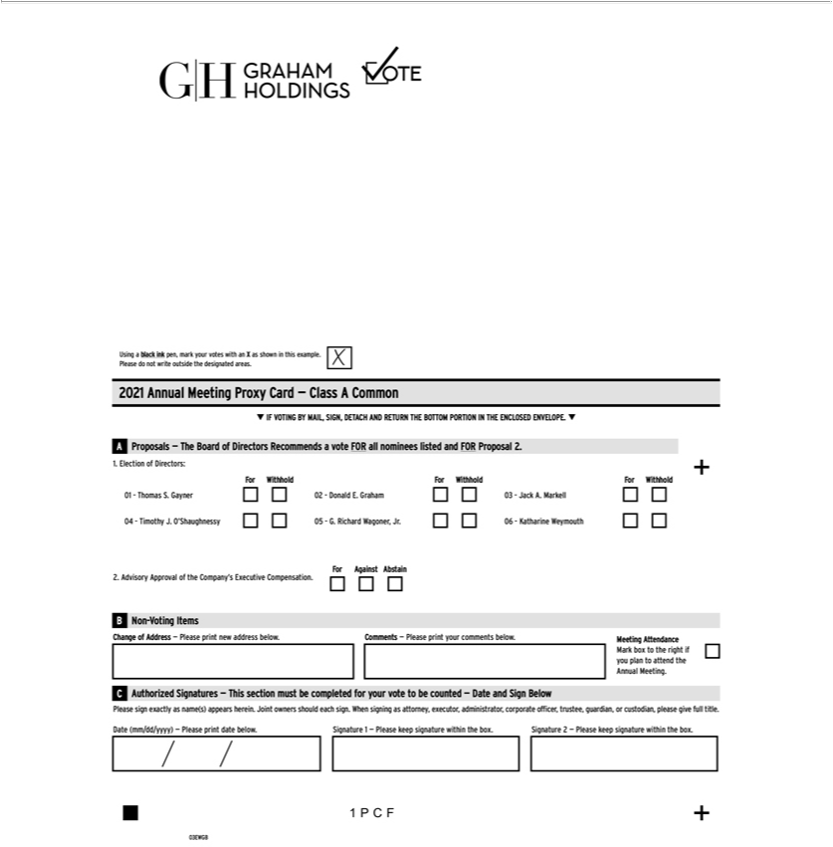

Using a black ink pen, mark your votes with an X as shown in this example. Please do not write outside the designated areas. 2021 Annual Meeting Proxy Card — Class A CommonIF VOTING BY MAIL,
ElectionSIGN,DETACHofDirectors:AND-ForRETURN-WithholdTHE-ForBOTTOM-Withhold-PORTIONFor-WithholdIN-THE+01 -ENCLOSEDThomas.Gayner02ENVELOPE.-DonaldAProposalsE.Graham03—The- JackBoardAbstainFor.ofMarkellDirectors04 Recommends-TimothyJ.O’Shaughnessy05voteFORallnominees-G.RichardlistedWagoner,andFOR Jr.06Proposal- 2.1. Katharine Weymouth For Against Abstain2. Advisory Approval of the Company’s Executive CompensationFor Against Against Abstain B Non-Voting Items Change of Address — Please print
completednewaddressforbelow.your voteCommentstobecounted—Please— printDate yourandSigncommentsBelowbelow.Please MeetingsignexactlyAttendanceasname(s)Markappearsboxtoherein.therightJointifyouownersplanshouldtoattendeachthe Annual.WhenMeeting.signingCasAuthorizedattorney,executor,Signaturesadministrator,—Thissectioncorporatemustbe
officer, trustee, guardian, or custodian, please give full title. Date (mm/dd/yyyy) — Please print date below. Signature 1 — Please keep signature within the box. Signature 2 — Please keep signature within the box. 1PCF03EWGB IF VOTING BY MAIL, SIGN, DETACH AND RETURN THE BOTTOM PORTION IN THE ENCLOSED ENVELOPE.Proxy — Graham Holdings Company

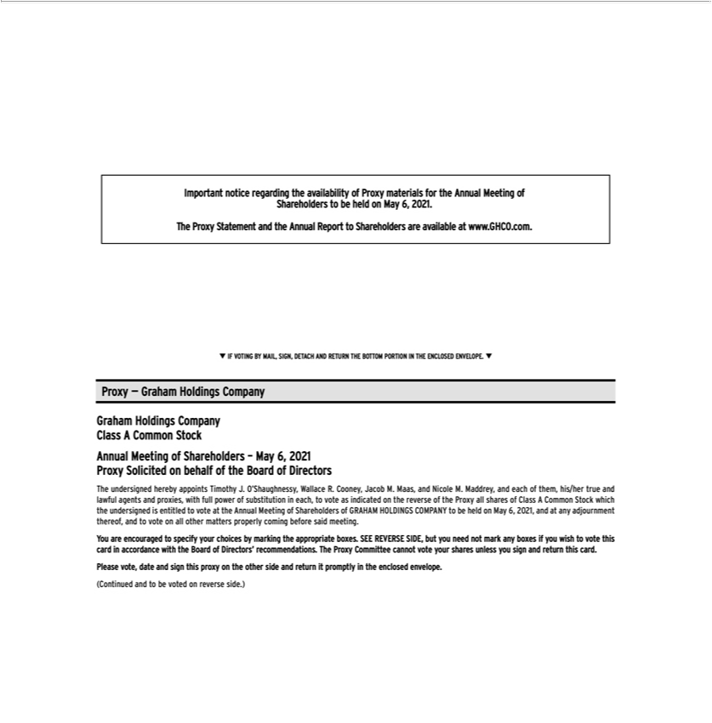

Important notice regarding the availability of Proxy materials for the Annual Meeting of Shareholders to be held on May 6, 2021. The Proxy Statement and the Annual Report to Shareholders are available at www.GHCO.com. Graham Holdings Company Class A Common Stock Annual Meeting of Shareholders – May 6, 2021 Proxy Solicited on behalf of the Board of Directors The undersigned hereby appoints Timothy J. O’Shaughnessy, Wallace R. Cooney, Jacob M. Maas, and Nicole M. Maddrey, and each of them, his/her true and lawful agents and proxies, with full power of substitution in each, to vote as indicated on the reverse of the Proxy all shares of Class A _{Common} Stock which the undersigned is entitled to vote at the Annual Meeting of Shareholders of GRAHAM HOLDINGS COMPANY to be held on May 6, 2021, and at any adjournment thereof, and to vote all other matters properly coming before said meeting. You are encouraged to specify your choices by marking the appropriate boxes. SEE REVERSE SIDE, but you need not mark any boxes if you wish to vote this card in accordance with the Board of Directors’ recommendations. The Proxy Committee cannot vote your shares unless you sign and return this card. Please vote, date and sign this proxy on the other side and return it promptly in the enclosed envelope. (Continued and to be voted on reverse side.)

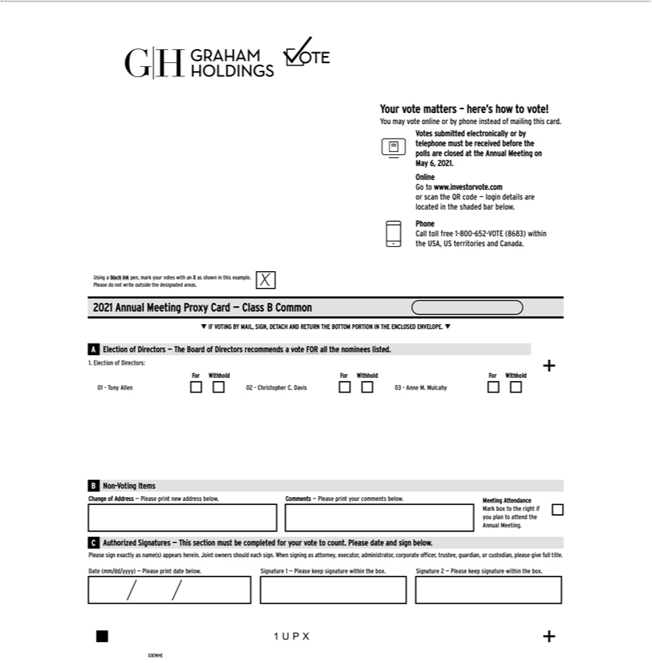

Your vote matters – here’s how to vote! You mayinvestorvoteonline or by phone instead of mailing this card. Votes submitted electronically or by telephone must be received before the polls are closed at the AnnualMeetingonMay6,2021.OnlineGotowww..comorscantheQRcode—logindetailsarelocatedintheshadedbarbelow.PhoneCalltollfree1-800-652-VOTE(8683)withintheUSA,US territories and Canada. Using a black ink pen, mark your votes with an X as shown in this example. Please do not write outside the designated areas. 2021 Annual Meeting Proxy Card – Class B Common IF VOTING BY MAIL, SIGN, DETACH AND RETURN THE BOTTOM PORTION IN THE ENCLOSED ENVELOPE. A Election of Directors — The Board of Directors recommends a vote FOR all theomineeslisted.1.ElectionofDirectors:ForWithholdForWithholdForWithhold01-onyAllen02-ChristopherC.Davis03-AnneM.MulcahyNon-VotingItemsChangeofAddress—Please new printaddressbelow.Comments—Pleaseprintyourcommentsbelow.MeetingAttendanceCAuthorizedSignatures—Thissectionmustbecompletedforyourvotetocount.Pleasedateandsignbelow. Please sign exactly name(s) appears herein. Joint owners should each . When signing as attorney, executor, administrator, corporate officer, trustee, guardian, or custodian, please give full title. Date
(mm/dd/yyyy) — Please print date below. Signature 1 — Please keep signature within the box. Signature 2 — Please keep signature within the box. 03EWHE 1UPX

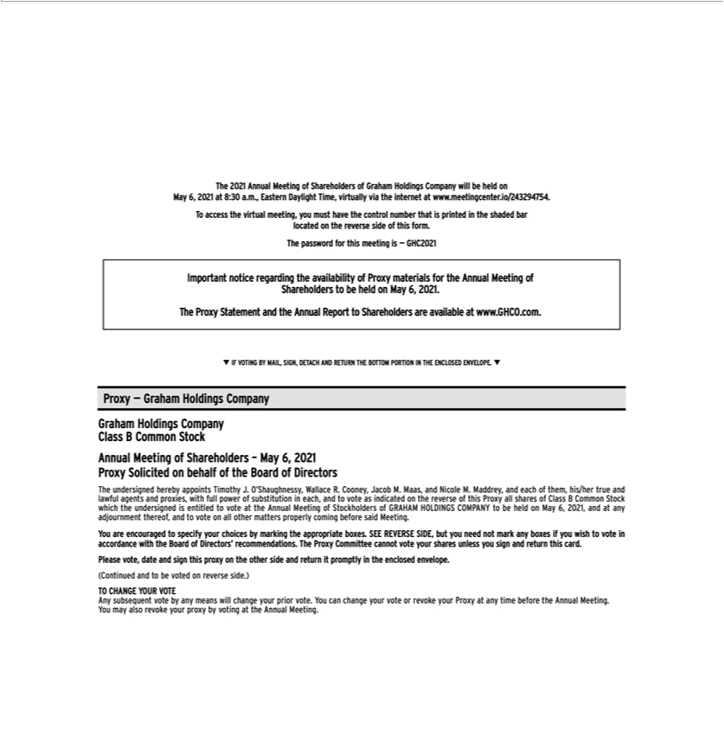

The 2021 Annual Meeting of Shareholders of Graham Holdings Company will be held on May 6, 2021 at 8:30 a.m., Eastern Daylight Theime, virtually via the internet at www.meetingcenter.io/243294754. Toaccessthevirtualmeeting,youmusthavethecontrolnumberthatisprintedintheshadedbarlocatedonthereversesideofthisform.passwordforthismeetingis—GHC2021Importantnotice regarding the availability of Proxy materials for the Annual Meeting of Shareholders to be held on May 6, 2021. The Proxy Statement and the Annual Report to Shareholders are available at www.GHCO.com. IF VOTING BY MAIL, SIGN, DETACH AND RETURN THE BOTTOM PORTION IN THE ENCLOSED ENVELOPE. Proxy — Graham Holdings Company Graham Holdings Company Class B Common Stock Annual Meeting of Shareholders – May 6, 2021 Proxy Solicited on behalf of the Board of Directors The undersigned hereby appoints Timothy J. O’Shaughnessy, Wallace R. Cooney, Jacob M. Maas, and Nicole M. Maddrey, and each of them, his/her true and lawfulMeetingagets and proxies, with full power of substitution in each, and to vote as indicated on the reverse of this ProxyllsharesofClassBCommonStockwhichtheundersignedisentitledtovoteattheAnnualofofGRAHAMHOLDINGSCOMPANYtobeheldonMay6,2021,andatany
adjournme t Stockholders
^{any} thereof, and to vote on all other matters properly coming before said Meeting. You are encouraged specify your choices by marking the appropriate boxes. SEE REVERSE SIDE, but you need
not mark boxes if you wish to vote in acco_{promptly}dancewith the Board of Directors’ recommendations. The Proxy Committee cannot vote your shares unless you sign and return this card. Please vote, date and
sign this proxy on the other side and return it in the enclosed envelope. (Continued and to be voted on reverse side.) TO CHANGE YOUR VOTE Any subsequent vote by any means will change your prior vote. You can change your vote or revoke your Proxy at any time before the Annual Meeting. You may also revoke your proxy by voting at the Annual Meeting.

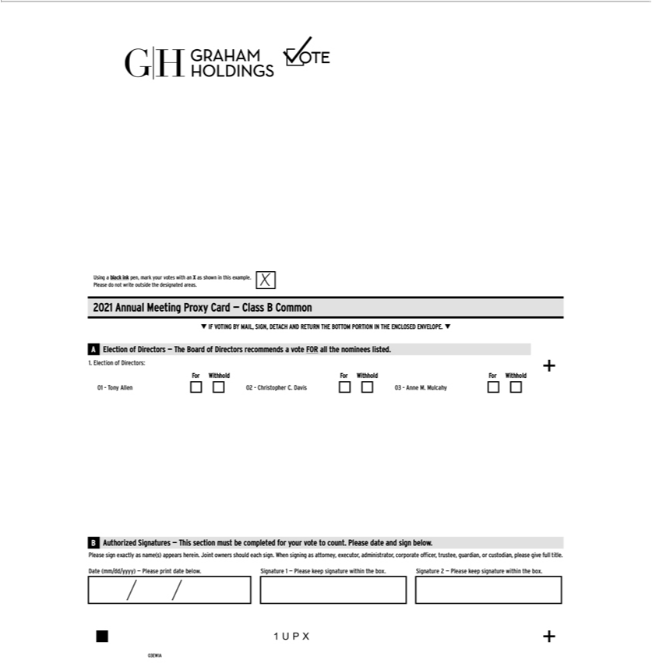

UsingSIGN, aDETACHblackink ANDpen,markRETURNyour votesTHE BOTTOMwithanX asPORTIONshownin INthisTHEexample.ENCLOSEDPleasedoENVELOPE.notwriteoutsideAElectionthedesignatedofDirectorsareas.— 2021TheBoardAnnualof MeetingDirectorsProxyrecommendsCard–ClassvoteBFORCommonalltheIFnomineesVOTINGlisted.BYMAIL,1.

Electionount.PleaseofDirectors:dateand ForsignWithholdbelow.PleaseForWithholdsignexactlyFor asWithholdname(s)01appears-Tonyherein.Allen02Joint-ChristopherownersshouldC.Daviseach 03 - .AnneWhenM.signingMulcahyasattorney,Authorizedexecutor,Signaturesadministrator,—Thiscorporatesectionmustofficer,becompletedtrustee,guardian,foryourorvote to
custodian, please give full title. Date (mm/dd/yyyy) — Please print date below. Signature 1 — Please keep signature within the box. Signature 2 — Please keep signature within the box. 1UPX 03EWIA

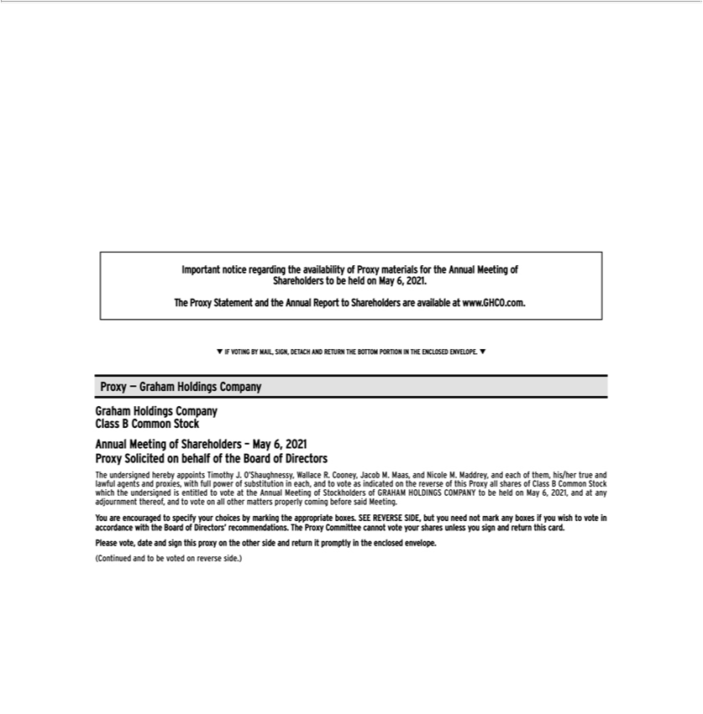

Important notice regarding the availability of Proxy materials for the Annual Meeting of Shareholders to be held on May 6, 2021. The Proxy Statement and the Annual Report to Shareholders are available at www.GHCO.com. IF VOTING BY MAIL, SIGN, DETACH AND RETURN THE BOTTOM PORTION IN THE ENCLOSED ENVELOPE Proxy — Graham Holdings Company Graham Holdings Company Class B Common Stock Annual Meeting of Shareholders – May 6, 2021 Proxy Solicited on behalf of the Board of Directors The undersigned hereby appoints Timothy J. O’Shaughnessy, Wallace R. Cooney, Jacob M. Maas, and Nicole M. Maddrey, and each of them, his/her true and lawfulMeetingagets and proxies, with full power of substitution in each, and to vote as indicated on the reverse of this ProxyllsharesofClassBCommonStockwhichtheundersignedisentitledtovoteattheAnnualofofGRAHAMHOLDINGSCOMPANYtobeheldonMay6,2021,andatany
adjournme t Stockholders
^{any} thereof, and to vote on all other matters properly coming before said Meeting. You are encouraged specify your choices by marking the appropriate boxes. SEE REVERSE SIDE, but you need
not mark boxes if you wish to vote in acco_{promptly}dancewith the Board of Directors’ recommendations. The Proxy Committee cannot vote your shares unless you sign and return this card. Please vote, date and
sign this proxy on the other side and return it in the enclosed envelope. (Continued and to be voted on reverse side.)

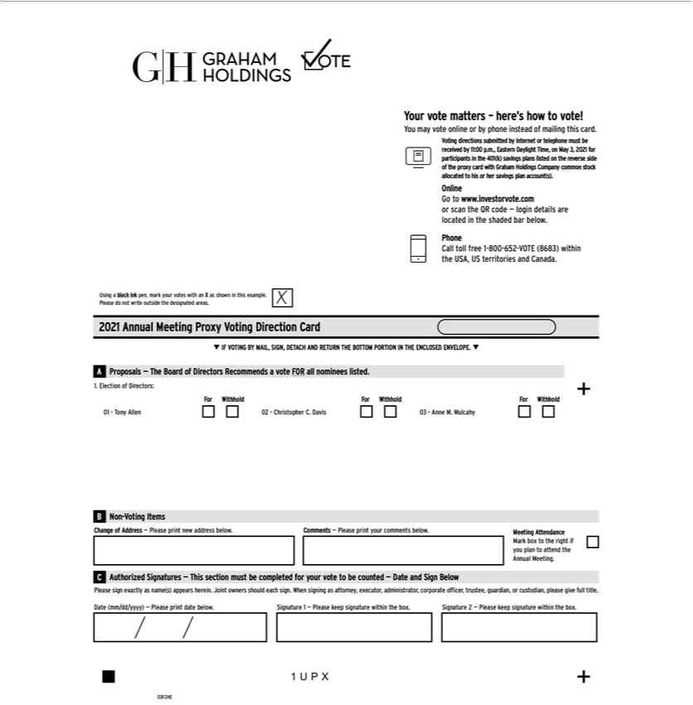

Your vote matters – here’s how to vote! You may vote online or by phone instead of mailing this ca d. Voting directions submitted by Internet or telephone must be received by 11:00 p.m., Eastern Daylight
Time, on May 3, 2021 for participants in the 401(k) savings plans listed on the reverse side of the proxy card with Graham Holdings Company common stock allocated to his or her savings plan account(s).
Online Go to www.investorvote.com or scan the QR code — login details are located in the shaded bar below. Phone Call toll free 1-800-652-VOTE (8683) within the USA, US territories and Canada. Using
a black ink pen, mark your votes with an X as shown in this example. Please do not write outside the designated areas. 2021 Annual Meeting Proxy Voting Direction Card IF VOTING BY MAIL, SIGN,
DETACH AND RETURN THE BOTTOM PORTION IN THE | ENVELOPE. A Proposals — The Board of Directors Recommends a vote FOR all nominees listed. 1. Election of Directors: For
Withhold For Withhold For Withhold 01 - Tony Allen 02 - ChristopherENCLOSED.Davis 03 - Anne M. Mulcahy B Non-Voting Items Change of Address — Please print new address below. Comments — Please print
your comments below. Meeting Attendance Mark box to the right if you plan to attend the Annual Meeting. C Authorized Signatures — This section must be completed for your vote to be counted — Date
and Sign Below Please sign exactly name(s) appears herein. Joint owners should each |  | . When signing as attorney, executor, administrator, corporate officer, trustee, guardian, or custodian, please give
full title. Date (mm/dd/yyyy) — Please print date below. Signature 1 — Please keep signature within the box. Signature 2 — Please keep signature within the box. 1UPX 03F2HE

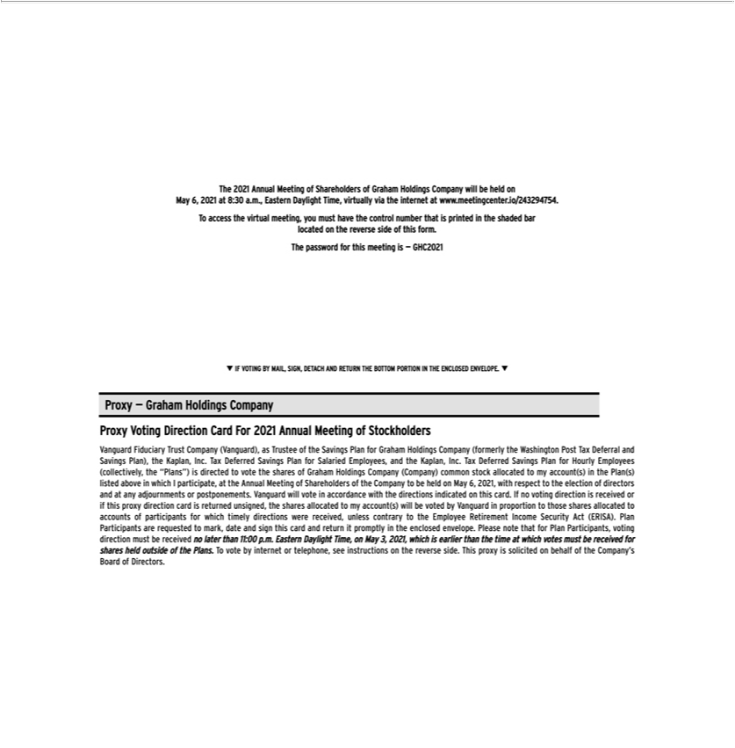

The 2021 Annual Meeting of Shareholders of Graham Holdings Company will be held on May 6, 2021 at 8:30 a.m., Eastern Daylight Theime, virtually via the internet at www.meetingcenter.io/243294754. To
StockholdersaccessIGN,theDETACHvirtual ANDmeeting,RETURNyoumustTHEhaveBOTTOMthecontrolPORTIONnumber thatINTHEisprintedENCLOSEDintheshadedENVELOPE.barlocatedProxyon the— GrahamreversesideHoldingsofthisCompanyform. ProxypasswordVotingforDirectionthismeetingCardisFor— GHC2021AnnualIF VOTINGMeetingofBY MAIL, Vanguard Fiduciary Trust Company (Vanguard), as Trustee of the Savings Plan for Graham Holdings Company (formerly the Washington Post Tax Deferral and Savings Plan), the Kaplan, Inc.
CompanyTaxDeferred(Company)Savings commonPlanforSalariedstock Employees,tomyandaccount(s)theKaplan,intheInc.Plan(s)TaxDeferredlistedaboveSavingswhichPlan forIparticipate,HourlyEmployeesattheAnnual(collectively,Meeting oftheShareholders“Plans”)isdirectedoftheCompanytovotethetosharesbeheldofonGrahamMay6,Holdings2021,with
respect to the election of directors andallocatedanyadjournments or postponements. Vanguard will vote in accordance with the directions indicated on this card. If no voting direction is received or if this proxy direction card is returned unsigned, the shares allocated^{Income}toy account(s) will be voted by Vanguard in proportion to those shares allocated to accounts of participants for which timely directions were

_{received,} unless contrary to the Employee Retirement Security Act (ERISA). Plan Participants are requested to mark, date and sign this card and return it promptly in the enclosed envelope. Please _{outside}nothat for Plan Participants, voting direction must be received no later than 11:00 p.m. Eastern Daylight Time, on May 3, 2021, which is earlier than the time at which votes must be received for shares held

of the Plans.To vote by internet or telephone, see instructions on the reverse side. This proxy is solicited on behalf of the Company’s Board of Directors.

